BA706_ Applied Analytic Modeling | Final Project: Airline Passenger Satisfaction  
Centennial College  
From: Nguyen Vuong Hoai Vu (301131497)  
For: Prof. David Parent  
Due date: Apr. 16th, 2021



# INTRODUCTION

## Background

I create this report as the final project for the course **BA706 “Applied Analytic Modeling” on April 16th, 2021**. This report aims to analyze a big data set called “US Airline Passenger Satisfaction” (D, 2018) using different types of analysis techniques and models that have been acquired during the course. As a result, I try to find the best fit model to predict the outcome of passenger satisfaction level toward airline services. All the analyses are completed using SAS 9.4| Enterprise Miner. This report is for academic purposes only.

The Business Objective is to increase turnover by direct improvement in providing services, this report tries to address what factors are currently impacting the satisfaction level of a US Airline’s passengers and tries to recommend what services need focusing to improve and whatnot.

## Data set introduction

This data set is the outcome of a US Airline’s passengers satisfaction survey which mainly measures the satisfaction levels of thousands of passengers toward the airline’s services. This data set is downloaded from the open sources website: Kaggle.com (D, 2018). The data set includes 129,880 rows and 24 columns that represent 129,880 surveys from passengers and 24 variables. The detailed information is shown in Table 1:

|  |  |  |  |  |  |
| --- | --- | --- | --- | --- | --- |
| No. | Labels | Descriptions | Code | Roles | Levels |
| 1 | ID | ID |  | ID | INTERVAL |
| 2 | Satisfaction | Airline satisfaction level | Satisfied,  neutral or dissatisfied | Target | BINARY |
| 3 | Age | The actual age of the passengers | 7 - 70 years old | Input | INTERVAL |
| 4 | Gender | Gender of the passengers | Female, Male | Input | BINARY |
| 5 | Customer Type | The customer type | Loyal customer, disloyal customer | Input | BINARY |
| 6 | Class | Travel class in the plane of the passengers | Business, Eco, Eco Plus | Input | NOMINAL |
| 7 | Type of Travel | Purpose of the flight of the passengers | Personal Travel, Business Travel | Input | BINARY |
| 8 | Arrival Delay in Minutes | Minutes delayed when Arrival |  | Input | INTERVAL |
| 9 | Departure Delay in Minutes | Minutes delayed when departure |  | Input | INTERVAL |
| 10 | Flight distance | The flight distance of this journey |  | Input | INTERVAL |
| 11 | Baggage handling | Satisfaction level of baggage handling | 0: Not Applicable;1-5 | Input | ORDINAL |
| 12 | Check-in service | Satisfaction level of Check-in service | 0: Not Applicable;1-5 | Input | ORDINAL |
| 13 | Cleanliness | Satisfaction level of Cleanliness | 0: Not Applicable;1-5 | Input | ORDINAL |
| 14 | Departure/Arrival time convenient | Satisfaction level of Departure/Arrival time convenient | 0: Not Applicable;1-5 | Input | ORDINAL |
| 15 | Food and drink | Satisfaction level of Food and drink | 0: Not Applicable;1-5 | Input | ORDINAL |
| 16 | Gate location | Satisfaction level of Gate location | 0: Not Applicable;1-5 | Input | ORDINAL |
| 17 | Inflight entertainment | Satisfaction level of inflight entertainment | 0: Not Applicable;1-5 | Input | ORDINAL |
| 18 | Legroom service | Satisfaction level of Legroom service | 0: Not Applicable;1-5 | Input | ORDINAL |
| 19 | On-board service | Satisfaction level of On-board service | 0: Not Applicable;1-5 | Input | ORDINAL |
| 20 | Online boarding | Satisfaction level of online boarding | 0: Not Applicable;1-5 | Input | ORDINAL |
| 21 | Ease of Online booking | Satisfaction level of online booking | 0: Not Applicable;1-5 | Input | ORDINAL |
| 22 | Online support | Satisfaction level of online support | 0: Not Applicable;1-5 | Input | ORDINAL |
| 23 | Seat comfort | Satisfaction level of Seat comfort | 0: Not Applicable;1-5 | Input | ORDINAL |
| 24 | Inflight wifi service | Satisfaction level of the inflight wifi service | 0: Not Applicable;1-5 | Input | ORDINAL |

Table 1: List of data variables and details.

# DATA EXPLORATION

## Data importing

Firstly, the data set is imported to Enterprise Miner with an “Import Node”. SAS 9.4 automatically assign the roles and data types for each variable as shown in Figure 1 below

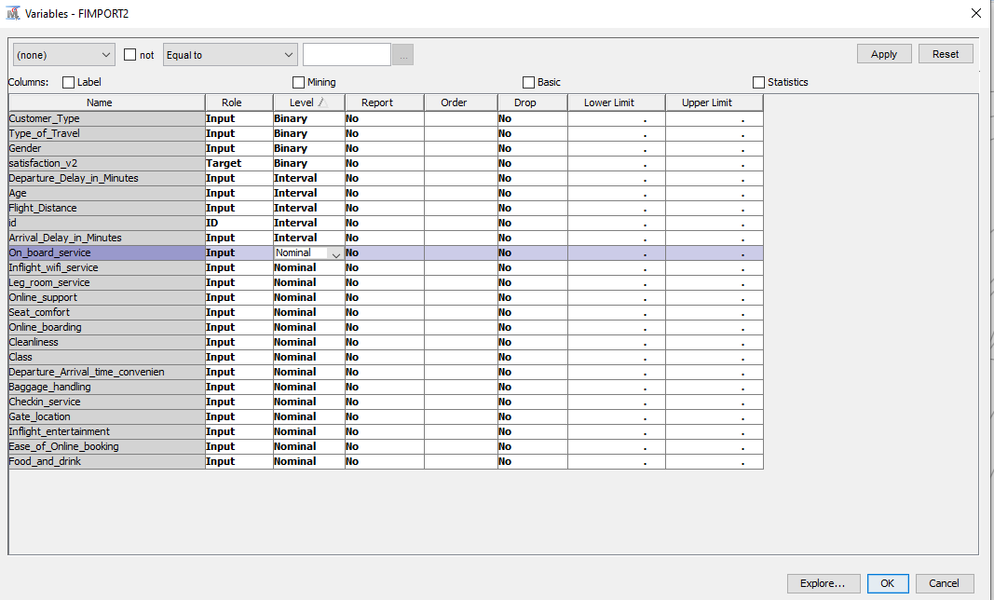

Figure 1: Variables’ roles and levels assigned by SAS automatically

In terms of roles, SAS automatically assigns 23 variables as INPUT and the last variable as ID, so I need to re-assign “satisfaction_v2” as the only TARGET.

In terms of levels, SAS assigns 4 nominal scale variables with only 2 values, such as Satisfaction, Customer Type… as binary level, 5 interval scale variables as interval level, and 15 variables as nominal level, of which, 14 satisfaction level variables need to be treated as ordinal scale variables, so I have re-assigned these variables into the ordinal level. The data set has been set as the Figure 2 below before go into further data processing.

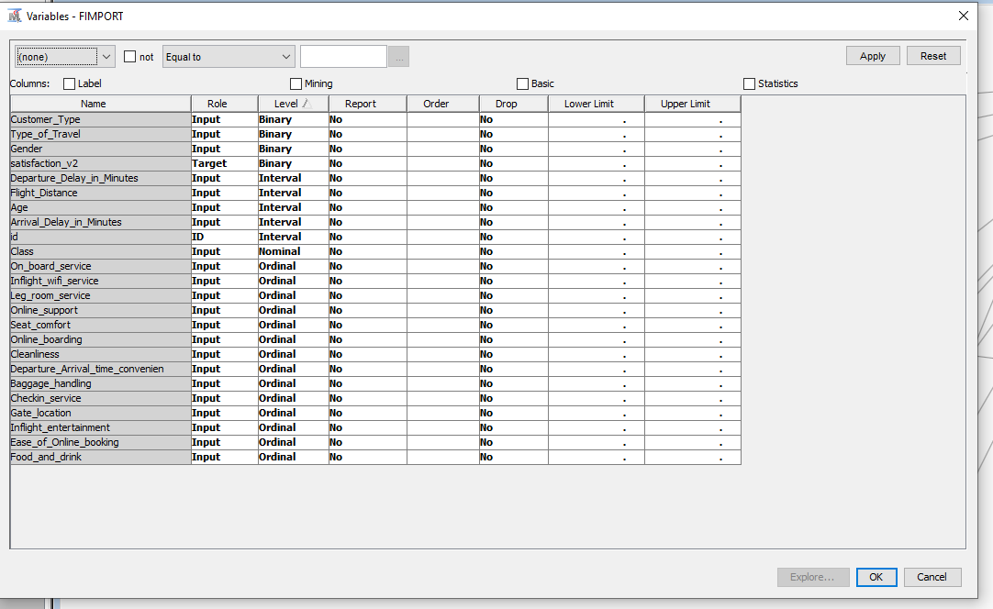

Figure 2: Variables’ roles and levels after re-assigned

## Data Exploration

To explore the data set and its variables, the Stat Explore node has been applied right after the Import Node, the result shows that this data set has:

* 2 skewed variables: Arrival Delay in Minutes, Departure Delay in Minutes
* There are 0.33% of missing values in the Arrival Delay in Minutes variable

To apply regression and neural network modelling, the missing values in the Arrival Delay in Minute need to be imputed and the replacements and transformations need to be applied to eliminate skewnesses.

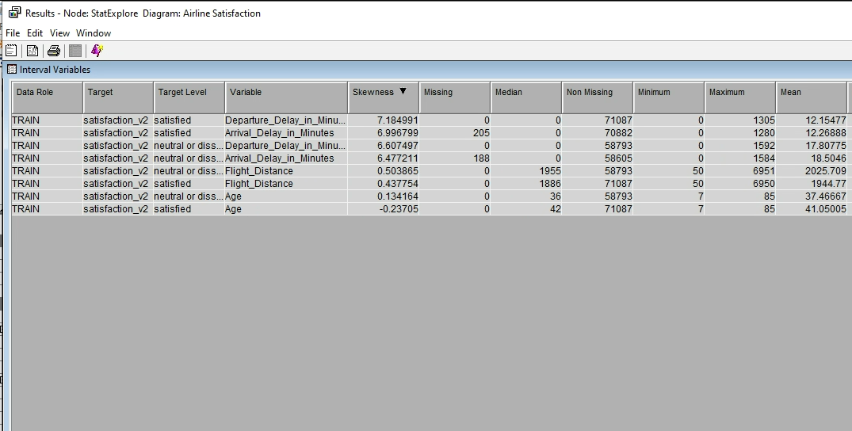

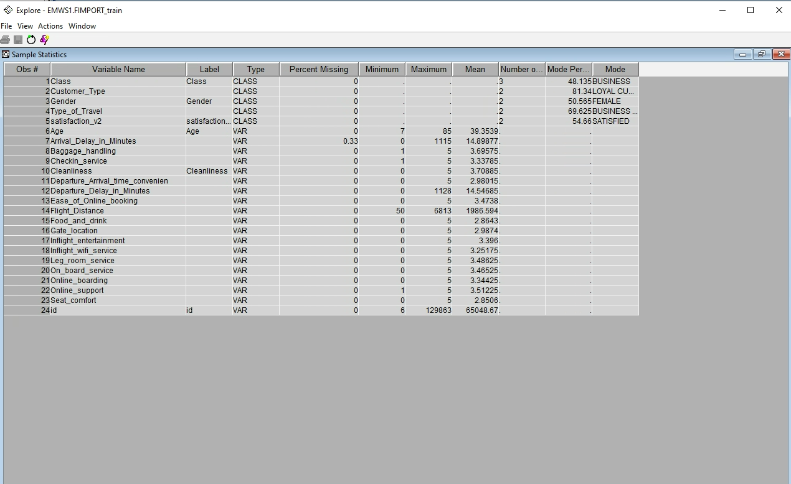

Figure 3: output of data exploration after the Importing Node

## Data partition

A really basic strategy to assess the data models is to partition the data source, in this case, the data source has been partitioned into 2 groups: training data with 50% of the data set using for finding the best fit model and validation data with the rest 50% using for validating the models. The sizes of 2 data set after dividing are the same, 64,940 samples, and the proportions of “satisfied” level of satisfaction variables are 54.73%

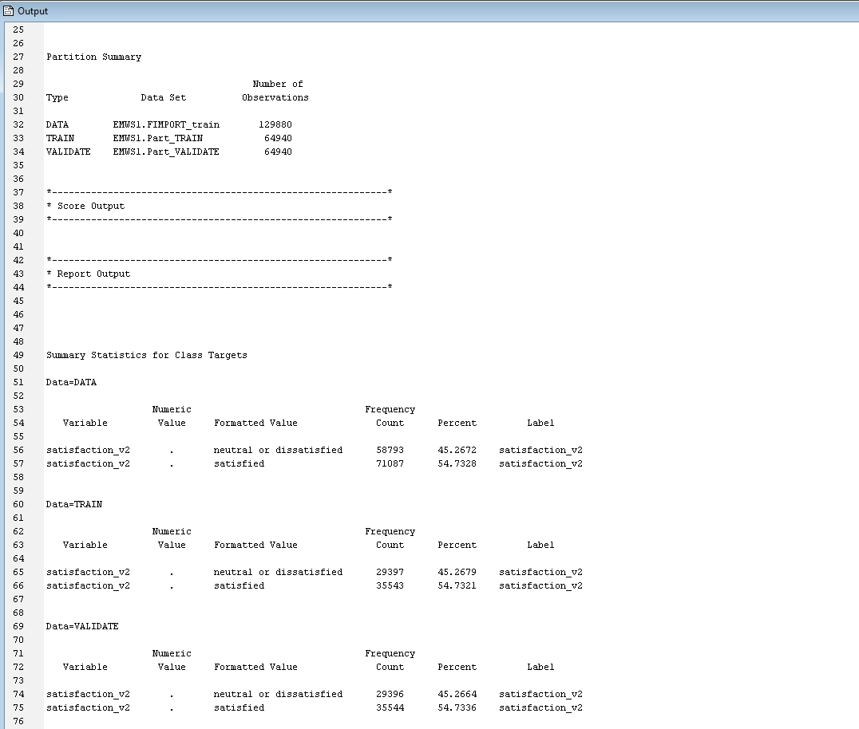

Figure 4: Data partition output

# DECISION TREE

We can run decision tree modelling with a “missing values” data set, so the “Maximum Tree”, “Misclassification Tree” and “ASE Tree” have been added right after the “Partition Node”.

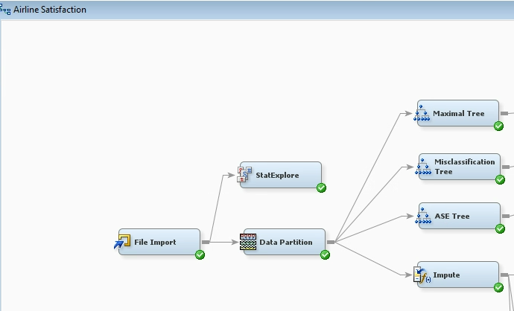

Figure 5: Decision Tree nodes

### Maximal Tree:

As the result, the “Maximal Tree” has a total of 39 leaves with the Average Square Error (ASE) of the 39th leave for the train, and validation data are 0.0745 and 0.0759 respectively. The most 3 important variables are: “In-flight entertainment”, “Seat comfort” and “Ease of online booking”. The detailed results are shown in Figure 6.

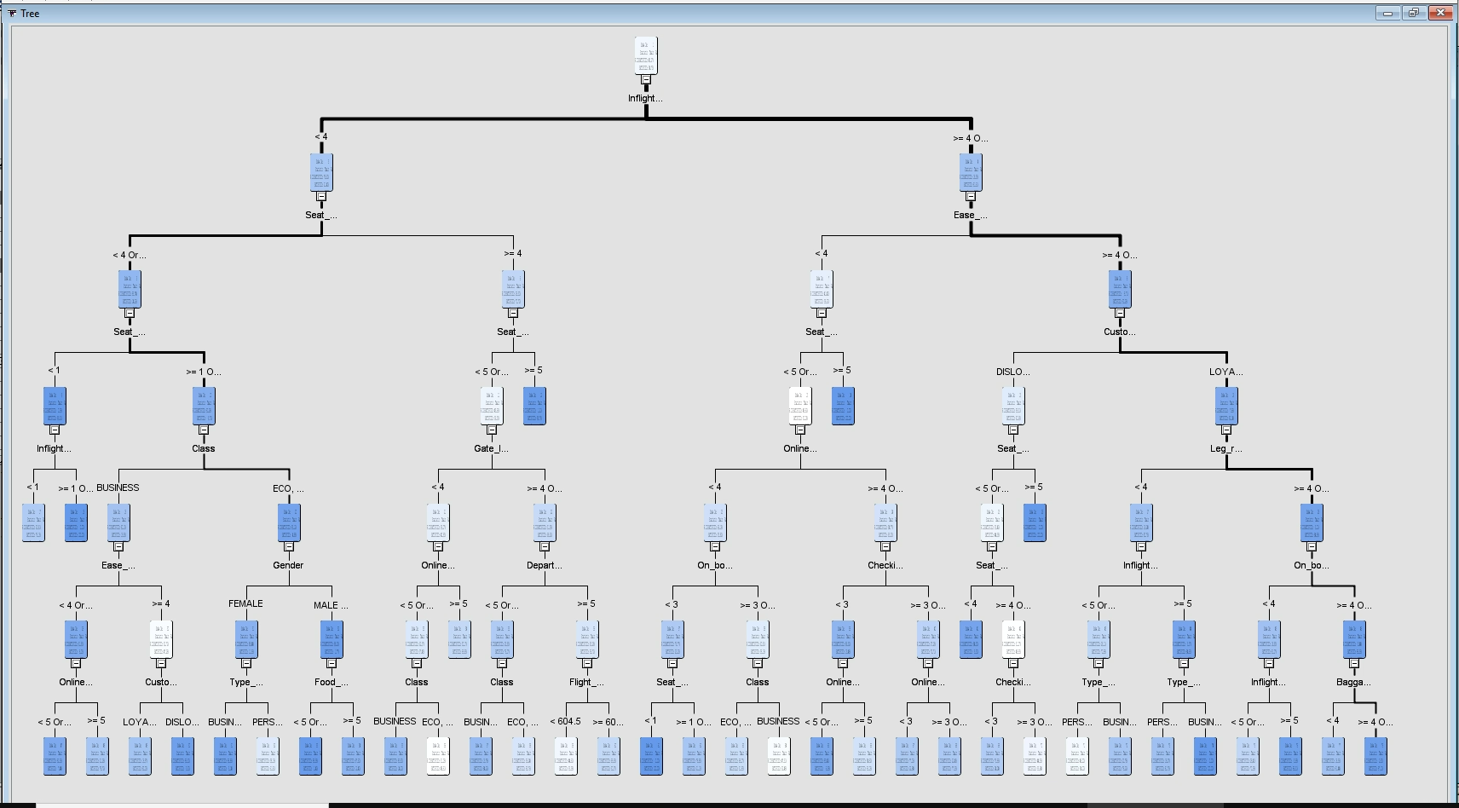

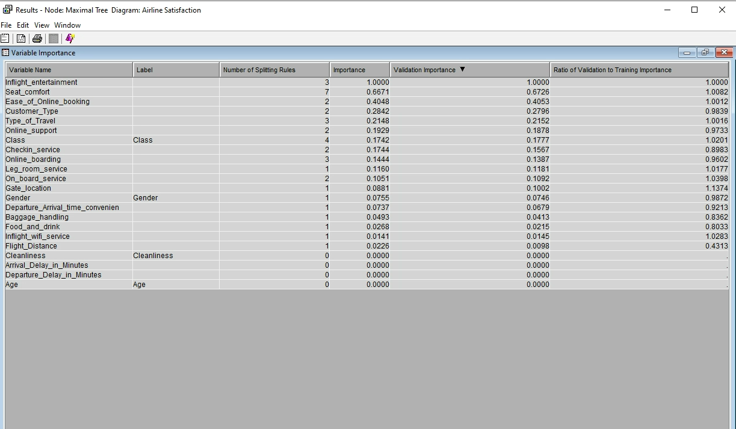

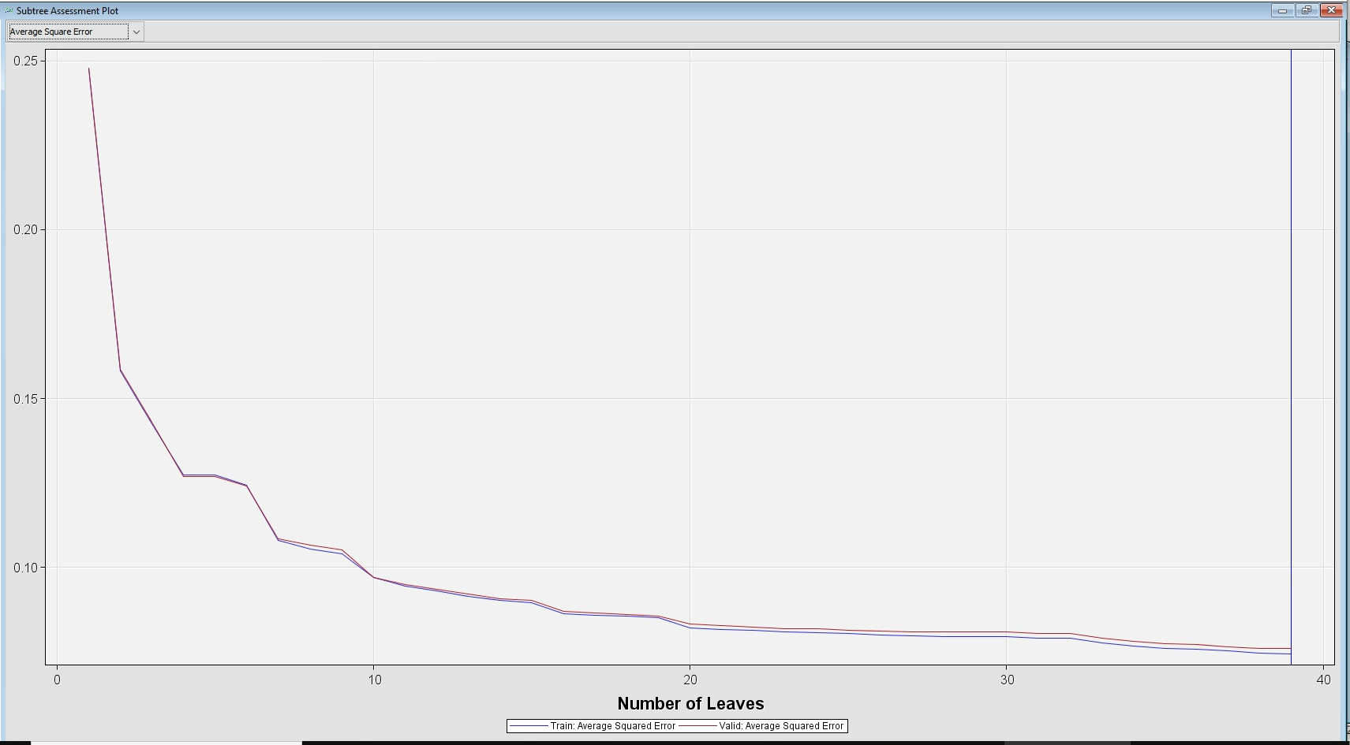

Figure 6: Maximal Tree output

### Misclassification Tree:

On the other hand, the “Misclassification Tree” has a total of 35 leaves, which means that the complexity of the tree is simpler than the Maximal Tree. The ASEs of the 35th leave for the train and validation data set are 0.0792 and 0.0804 respectively. Those are higher than the Maximal Tree. The Misclassification Tree is simpler but still too complex and the ASE is not good as the Maximal Tree so this is not a good model to choose. The most 3 important variables still are the same as the Maximal Tree. The detailed results are shown in Figure 7

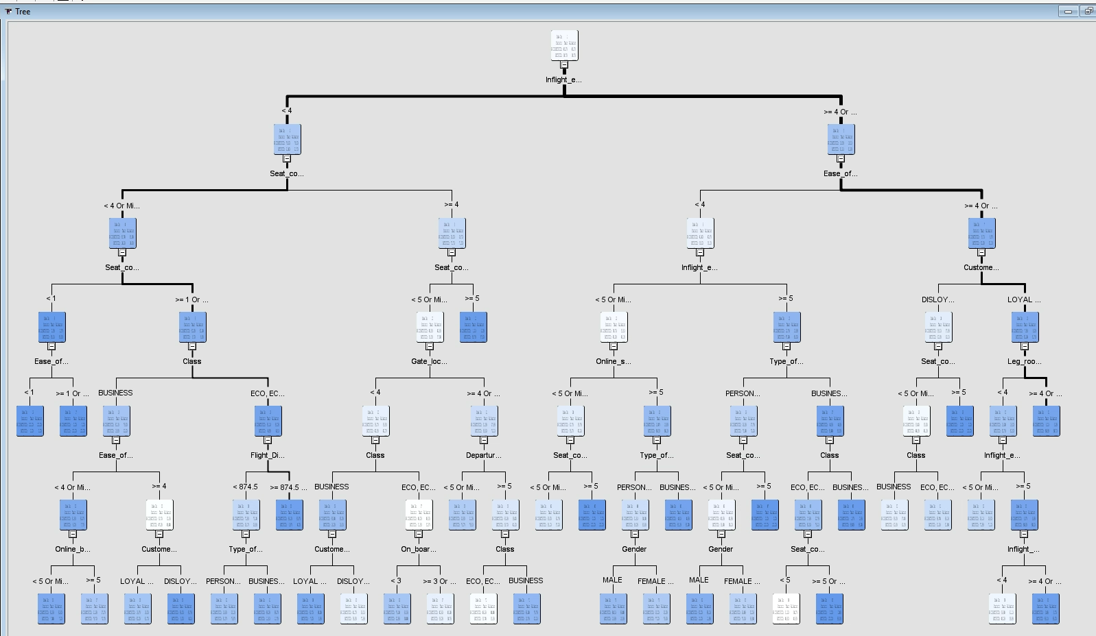 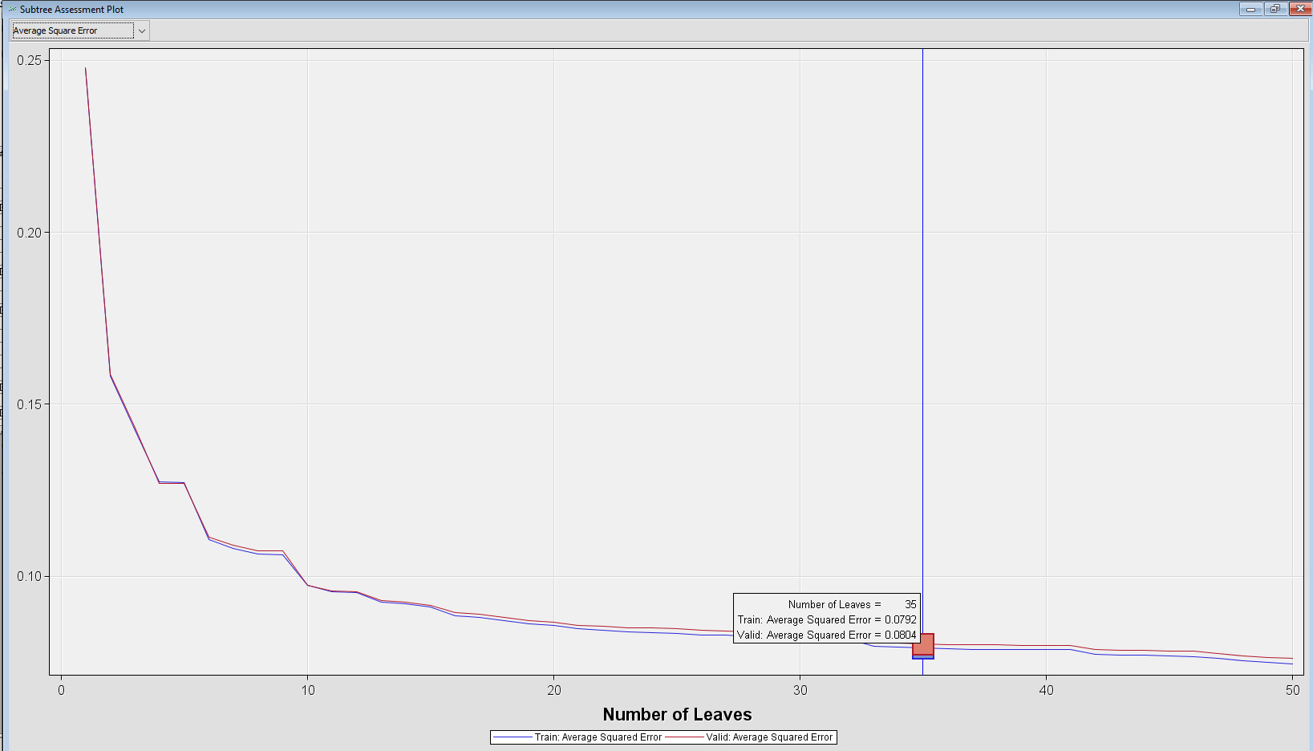

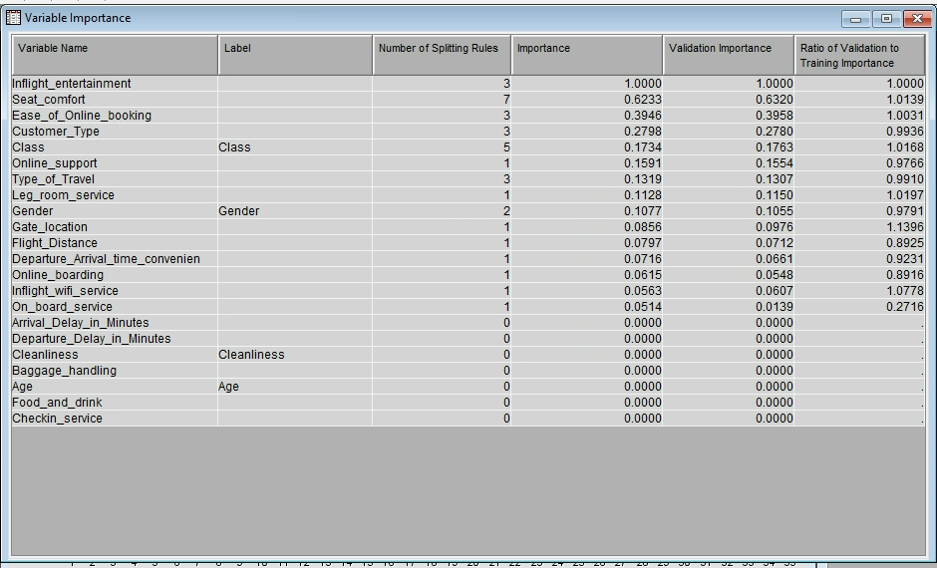

Figure 7: Misclassification Tree output

### ASE Tree:

Finally, the “ASE Tree” has a total of 48 leaves, this is a complex model and the ASEs of the 48th leave for the train and validation data set are 0.0745 and 0.0761 respectively. This model is better than the 2 previous models in terms of ASE. The most 3 important variables still are the same as the 2 other trees. The detailed results are shown in Figure 8

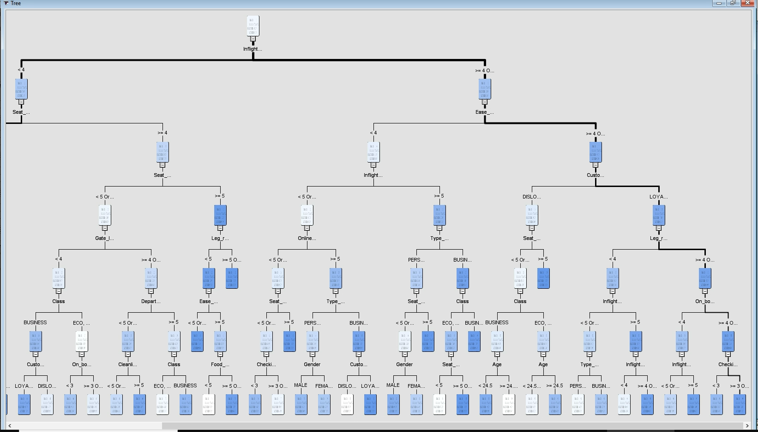

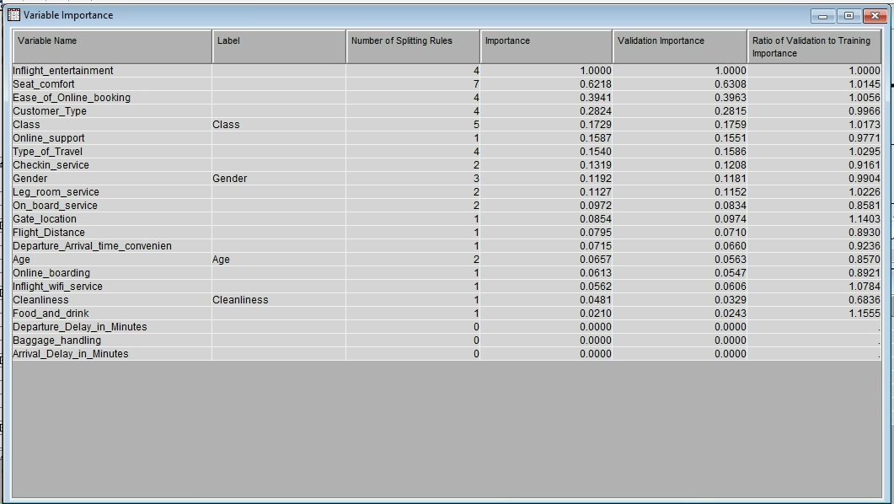

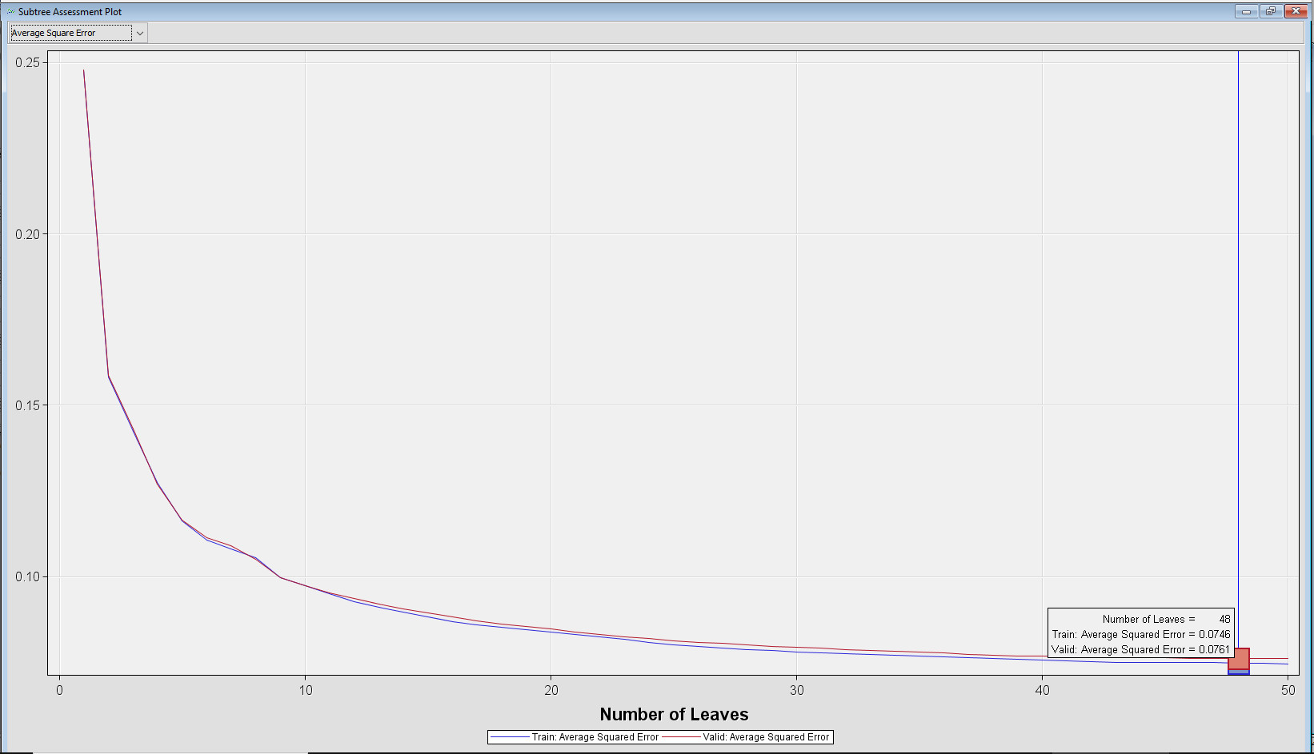

Figure 8: ASE Tree output

## Conclusion for Decision Tree:

If the criteria to choose the best model is the average error, the best tree could be ASE Tree with the vali. ASE of 0761. This model has 48 leaves which are still complex. The most important variables are: “In-flight entertainment”, “Seat comfort” and “Ease of online booking”, “Customer Type”.

***For further consideration, US Airlines can focus to improve the entertainment facilities during flight-time, especially for long flights, together with the improvement of seat comfort. Another thing to be focused on is the enhancement of online booking experiences. To answer “how to improve?”, this report will continue with more advanced models below.***

# DATA PREPARATION FOR REGRESSION AND NEURAL NETWORK MODELING

Because of the missing values and skewness, the Imputation Node needs to come in place for imputing the missing values, the Cap & Floor Node, and Log Transformation for narrowing down the skewness.

## Imputation Node

There are a total of 205 missing values for “Arrival Delay in Minutes” in the train data set that have been imputed by the average value of the arrival delay time. 2 more columns have been added to the input data which contain the imputed data and the indicator variable, this is to test whether the imputed values significantly affect the target outcome.

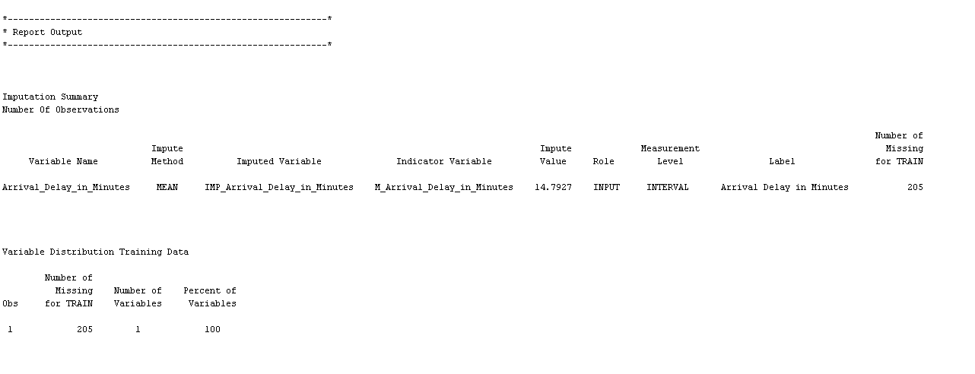

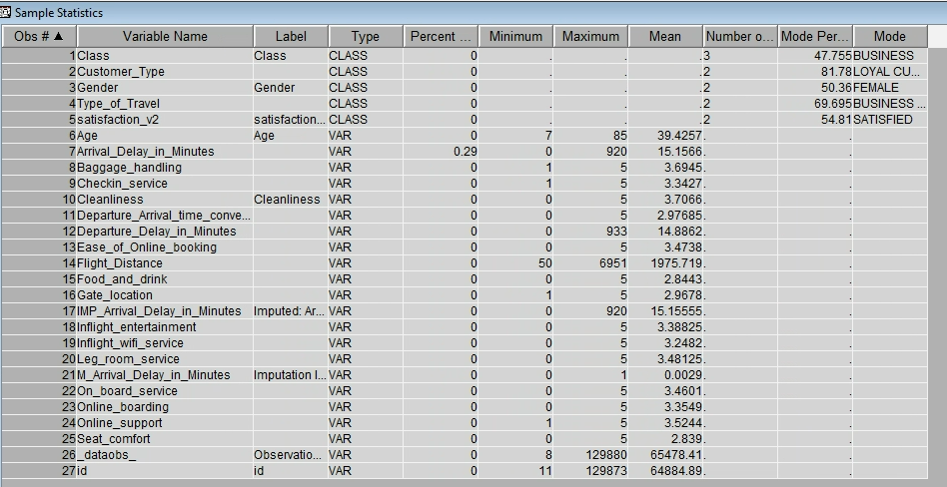

Figure 9: Imputation results

## Cap & Floor

From the output data of the Imputation Node, we can see the skewness still exists in 2 variables: Imputed Arrival Delay in Minutes, Departure Delay in Minutes with the skewness indexes of 6.1 and 6.0. The exploration of the input variables for the Stat Explore Node shows that there are outlier values for both two variables. The means are only around 14 minutes and the standard deviations are around 36 but the maximum delay times are around 1,110 minutes which means much higher than the 3 x standard deviation.

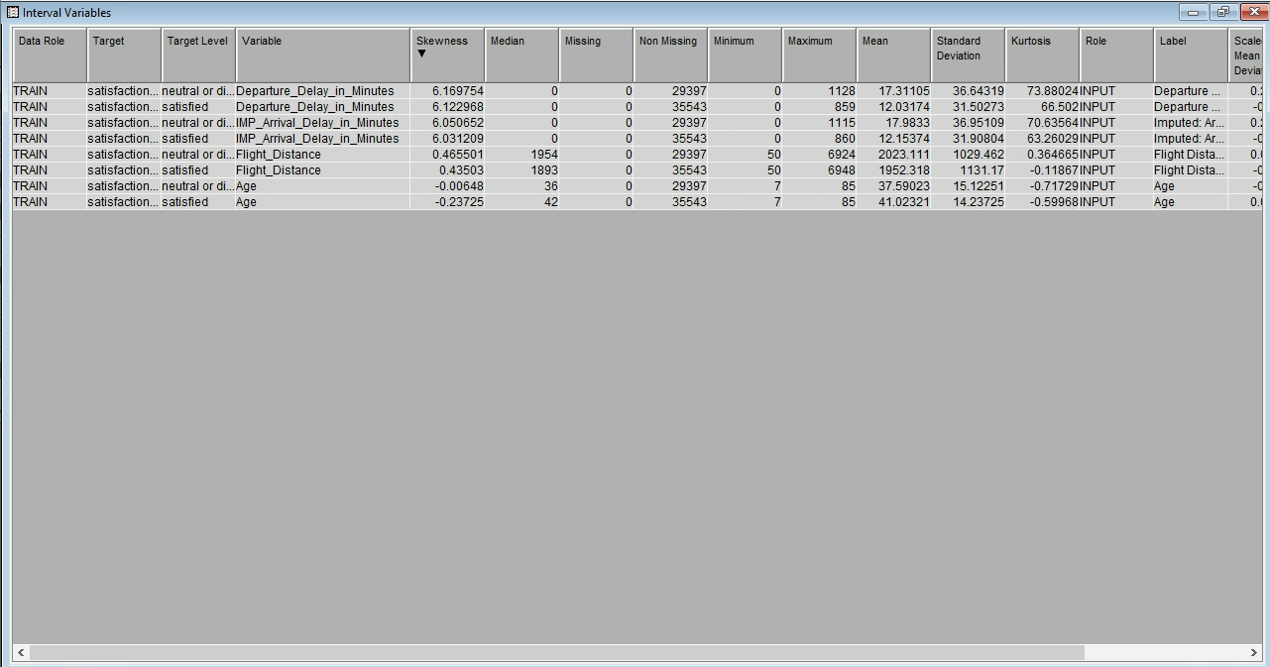

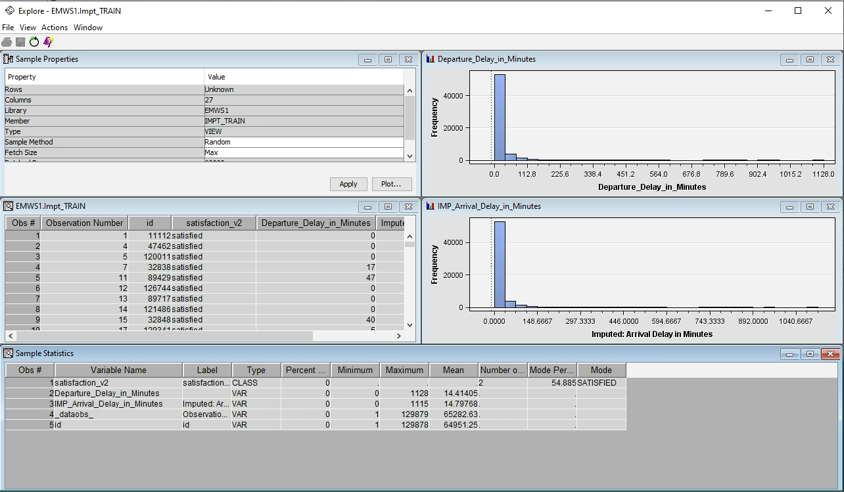

Figure 10: Stat Explorers results after Imputation Node

The Cap & Floor Node cap all the outliner values to 3 x standard deviation. In the effort to reduce skewness, there are :

* 1,389 outliner values in the training dataset and 1,533 in the validation data set have been replaced in the Departure_Delay_in_Minutes variable
* 1,421 outliner values in the training dataset and 1521 in the validation data set have been replaced in the IMP_Arrival_Delay_in_Minutes variable

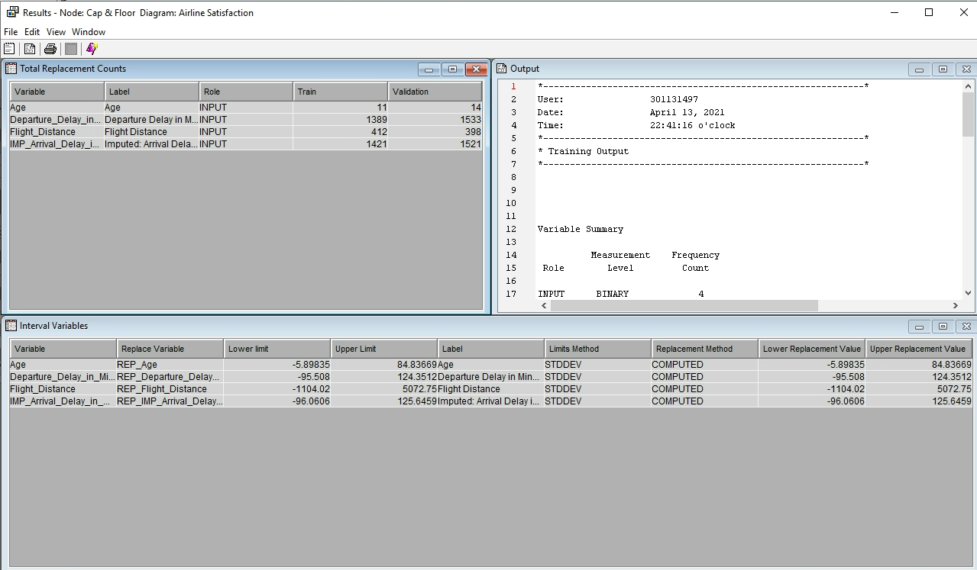

Figure 11: Cap & Floor output

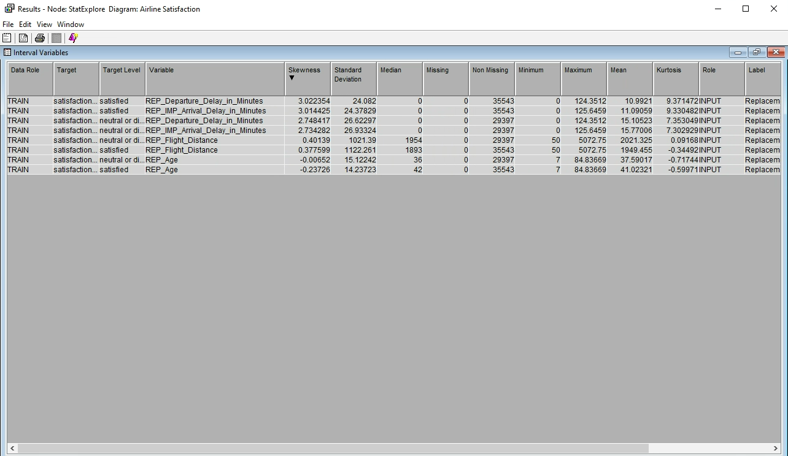

Figure 12: Stat Explores results after the Cap & Floor

The stat explores of internal variables shows that the skewness has been reduced from around 6 to around 3 for both 2 replaced variables. But the level of skewness is still higher than 2 so I decided to go with the Log Transformation Node with the hope of reducing the skewness

## Log Transformation

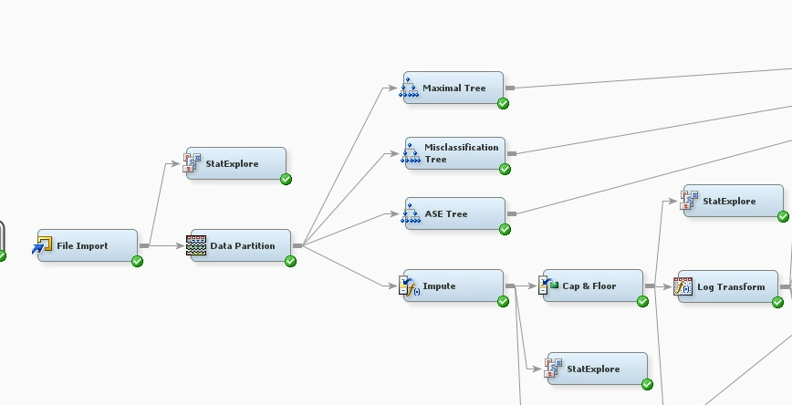

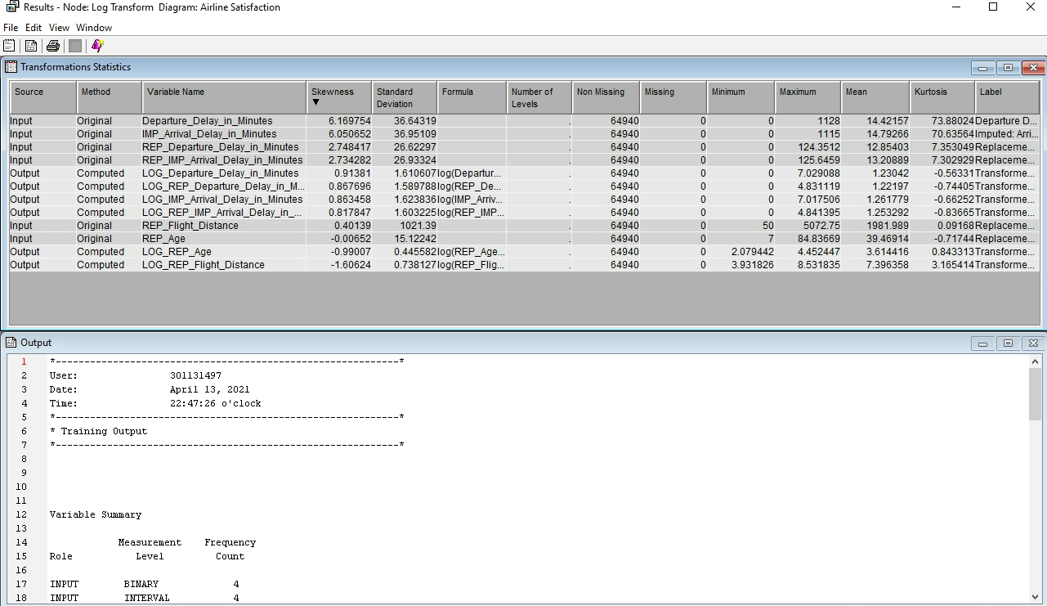

Figure 13: Log Transformation output

After Log Transformation Node, skewnesses have been reduced to under 1 point which is good for applying the next analysis models.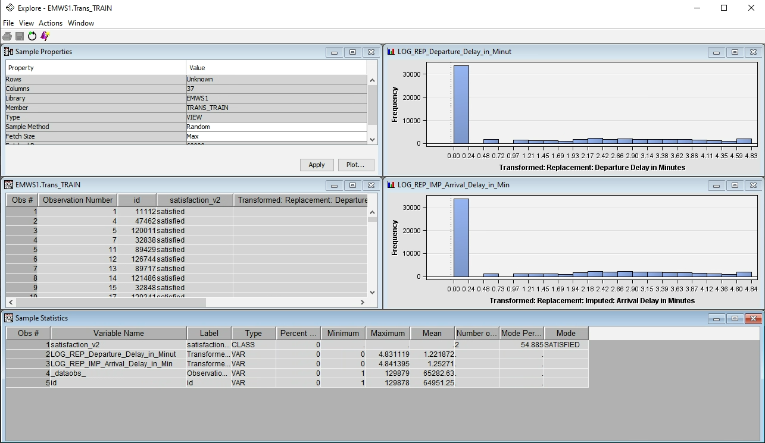

Figure 14: Exploration of output variables from Log Transformation Node

# REGRESSION MODELING

## Full Regression

The Full Regression model takes all the variables into the model and runs the test to see which variables affect significantly the Target. The result shows that most of the variables are impactful, only 2 variables with P values greater than 0.05 are the M_Arrival_Delay_in_Minutes and LOG_REP_Departure_Delay_in_Minutes

* The Departure Delay might not affect much the satisfaction level of the passengers and the imputation of missing values also not affect.
* Because most of the variables are impactful so it is not simplified much when we apply the next decision tree models such as Forward, Backward, and Stepwise.

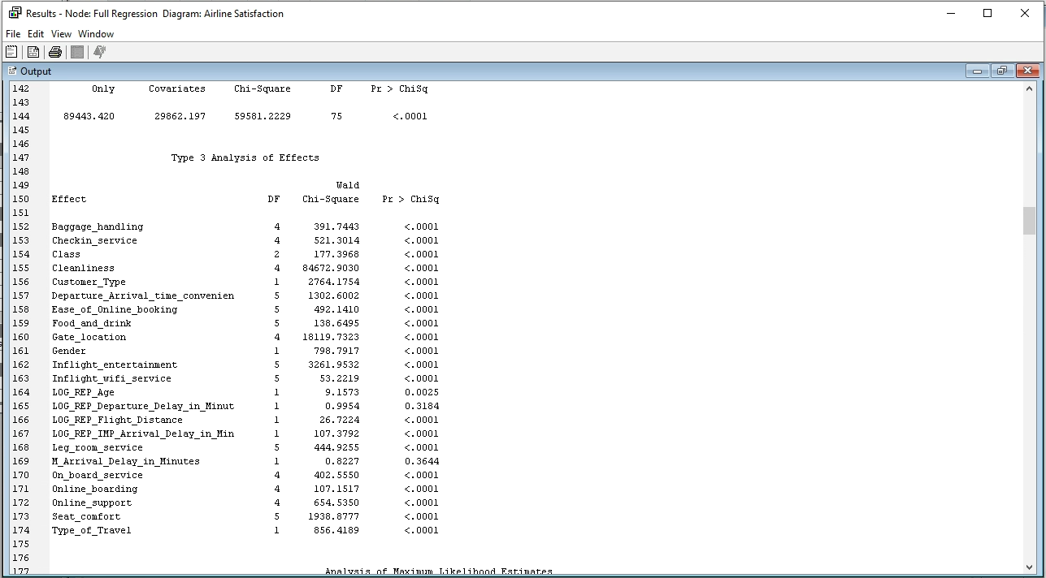

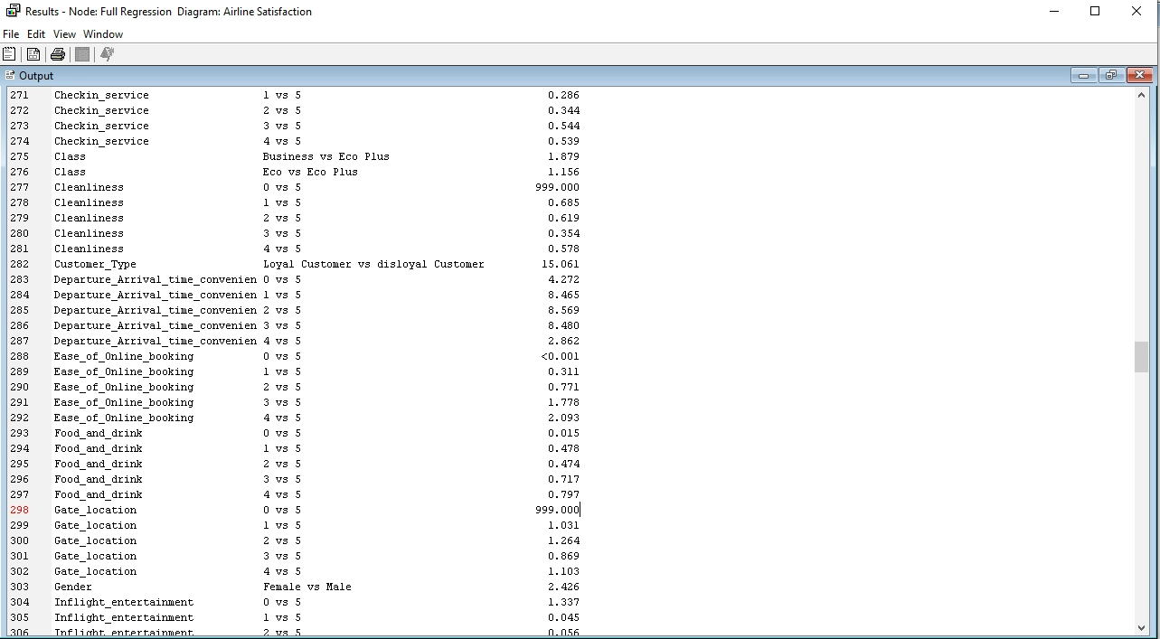

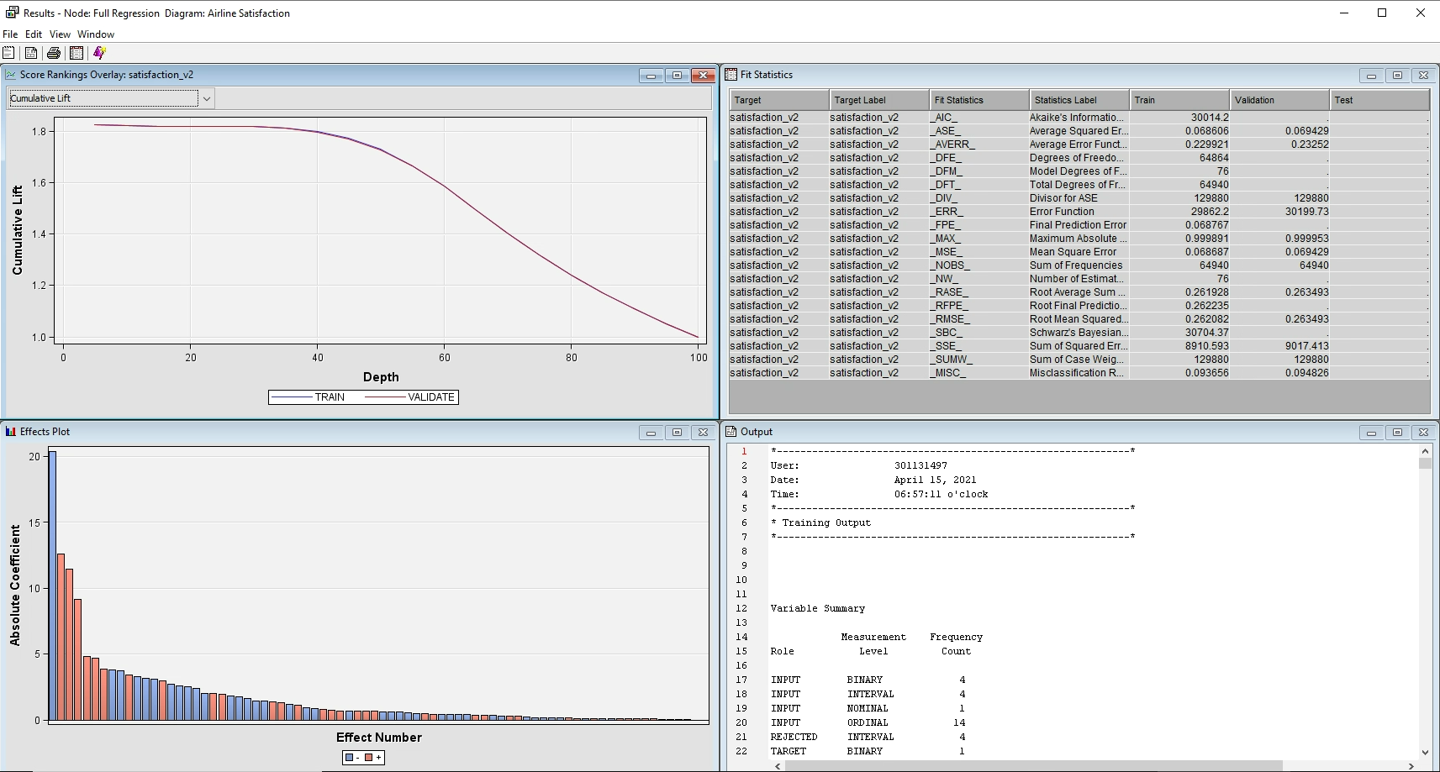

Figure 15: Full Regression output

The ASE of this model is 0.068 for the train data set and 0.069 for the validation data set which is smaller than all the Decision Tree models.

## Backward, Forward, and Stepwise Regression

The result for Backward Regression shows that most of the variables are impactful so there are only 2 steps backward that remove the Log_Rep_Departure_Delay_in_Minute and M_Arrival_Delay_in_Minutes variable out but the optimized model only has 1 step backward. The ASE of this model is 0.068 for train and 0.069 for validation data set which is nearly the same as the Full Regression since only 1 variable has been removed comparing with the Full Regression Model.

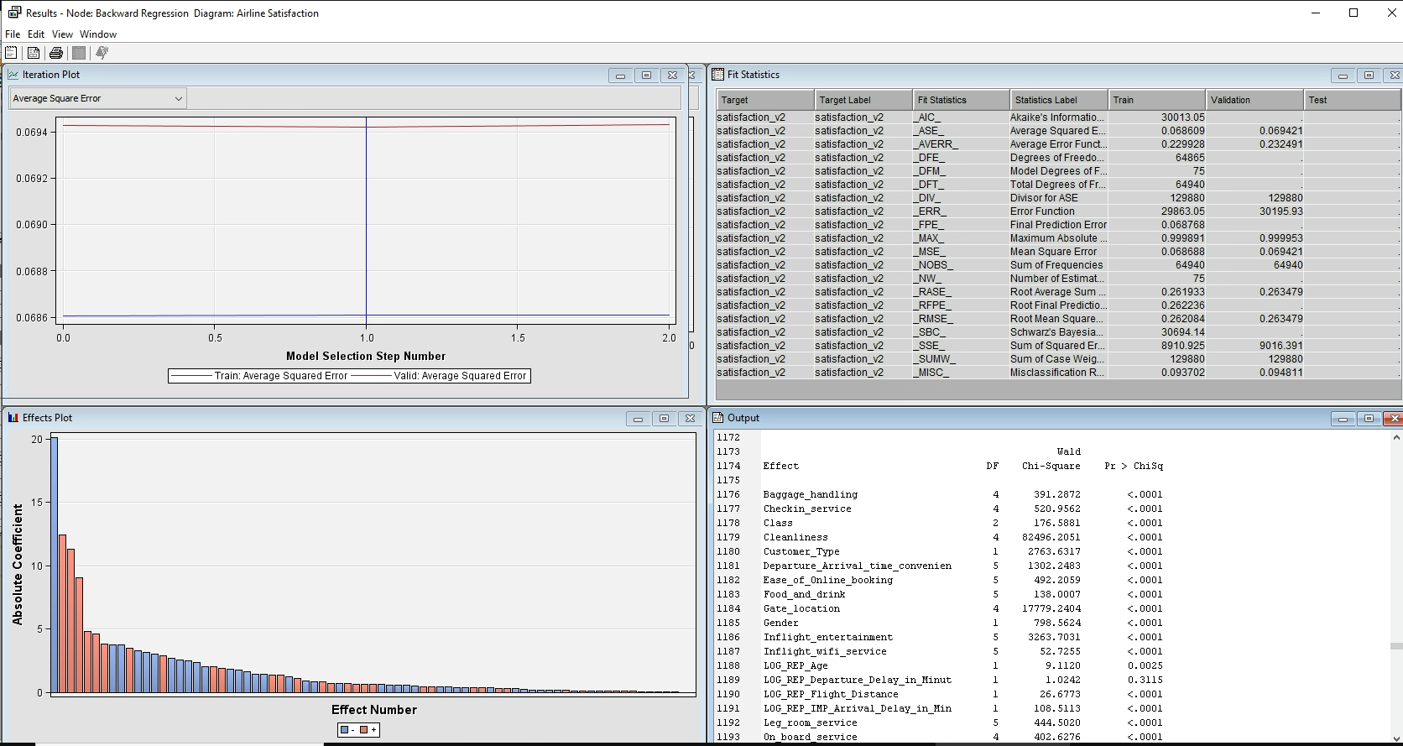

Figure 16: Backward Regression output

The results in the Forward and Stepwise Regression are nearly the same as the 2 previous models because most of the variables’ P values are smaller than 0.0001 which significantly affects the target. And the number of variables and ASEs are nearly the same too.

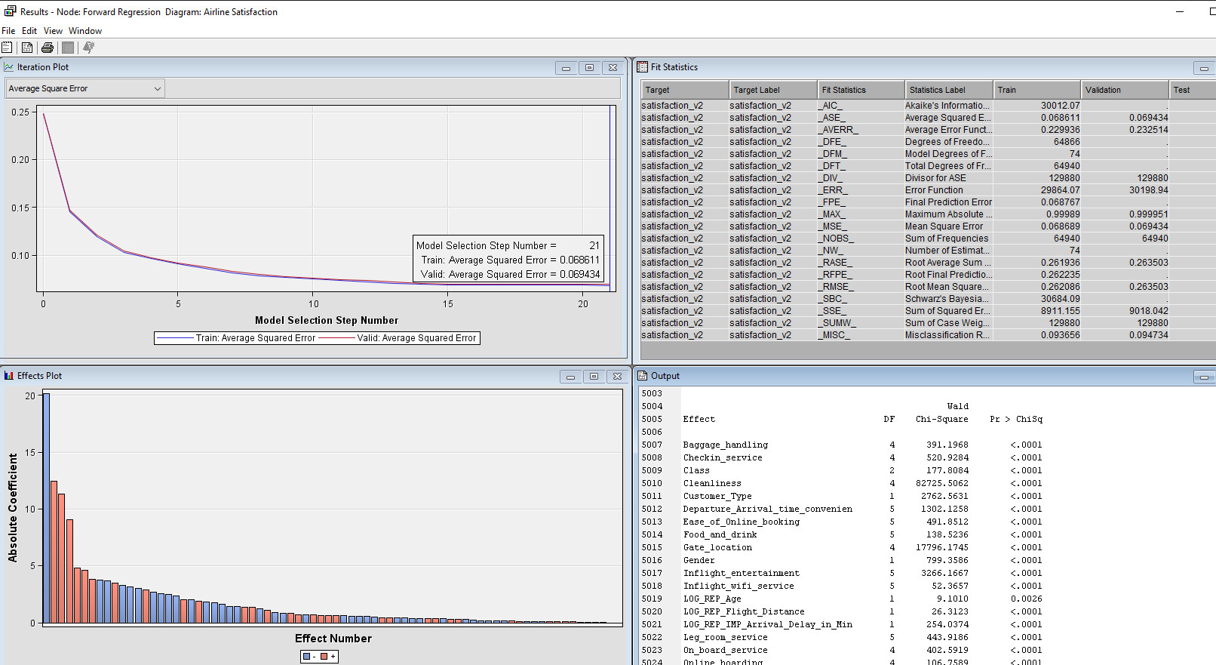

Figure 17: Forward Regression output

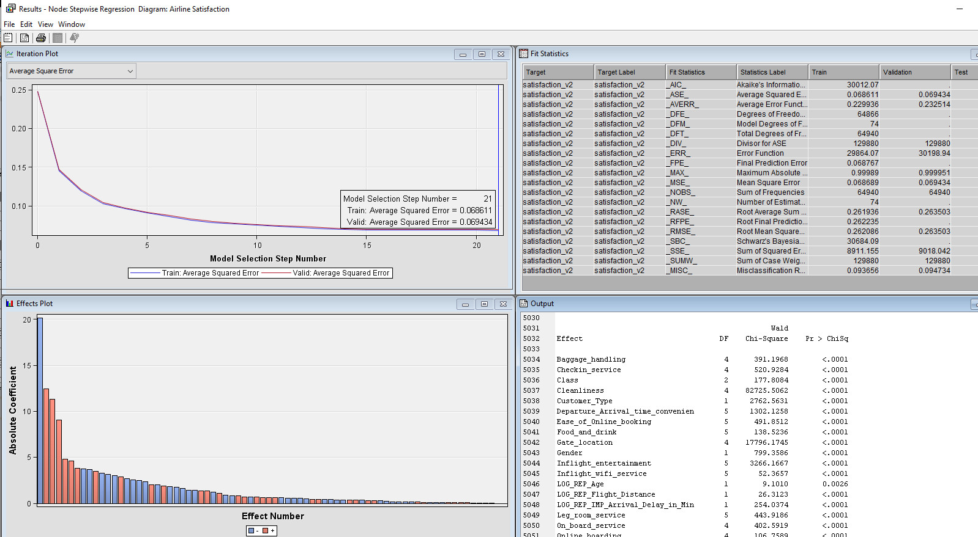

Figure 18: Stepwise Regression output

|  |  |  |  |  |
| --- | --- | --- | --- | --- |
|  | Steps | No. Variables | Important variables | ASE |
| Full Regression | N/A | 23 | Cleanness, Gate Location, In-Flight Entertainment, Seat_Comfort & Customer Type | 0.0686 (Train)  0.0694 (Vali.) |
| Backward Regression | 1 | 22 | Cleanness, Gate Location, In-Flight Entertainment, Seat_Comfort & Customer Type | 0.0686 (Train)  0.0694 (Vali.) |
| Forward Regression | 21 | 21 | Cleanness, Gate Location, In-Flight Entertainment, Seat_Comfort & Customer Type | 0.0686 (Train)  0.0694 (Vali.) |
| Stepwise Regression | 21 | 21 | Cleanness, Gate Location, In-Flight Entertainment, Seat_Comfort & Customer Type | 0.0686 (Train)  0.0694 (Vali.) |

Table : Regression models’ results

## Conclusion & Interpretation for Regression Models

As the results show, the regression models are not much different in terms of the number of significant variables, ASE, and important variables. Let’s take the forward as the best model since this model is less complex than others.

There 5 most important variables: Ease_of_Online_Booking, Cleanness, Gate Location, Customer Type & Seat_Comfort, with the highest wald chi-square.



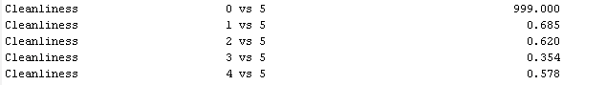

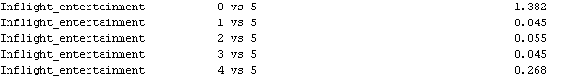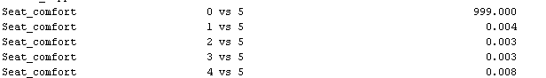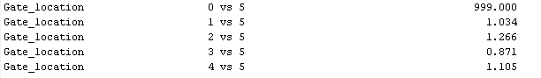

Figure 19: Odds ratio estimated of the most important variables

Loyal passengers are more likely to be satisfied with the company’s services than disloyal passengers - more than 14 times (1,4039 %), so it is more necessary to focus on the disloyal customers to increase their loyalty by improving our services. One of the most important things that need to be improved is cleanness, people that are highly satisfied with our cleaning service are 31.5% - 64.6% more likely to be satisfied with our overall services than other passengers that are not satisfied or feel normal with our cleanness level. The level of seat comfort is also important, passengers might be nearly 96% satisfied with our services if they feel comfortable with the seat they take during flights. The company also needs to care about the gate location of the flights, they need to be more convenient and the entertainment programs during flights need to be more attractive too.

## Dummies recoding

In the hope of reducing the complexity of the optimal model, I tried to replace all the satisfaction level variables with the dummies variables. The dummies recoding rules are as the Table 3 below:

|  |  |
| --- | --- |
| Original values | New values |
| 0 | 0 |
| 1 | 1 (Neutral or dissatisfied) |
| 2 | 1 (Neutral or dissatisfied) |
| 3 | 1 (Neutral or dissatisfied) |
| 4 | 2 (Satisfied) |
| 5 | 2 (Satisfied) |

Table : Recoding dummies rules

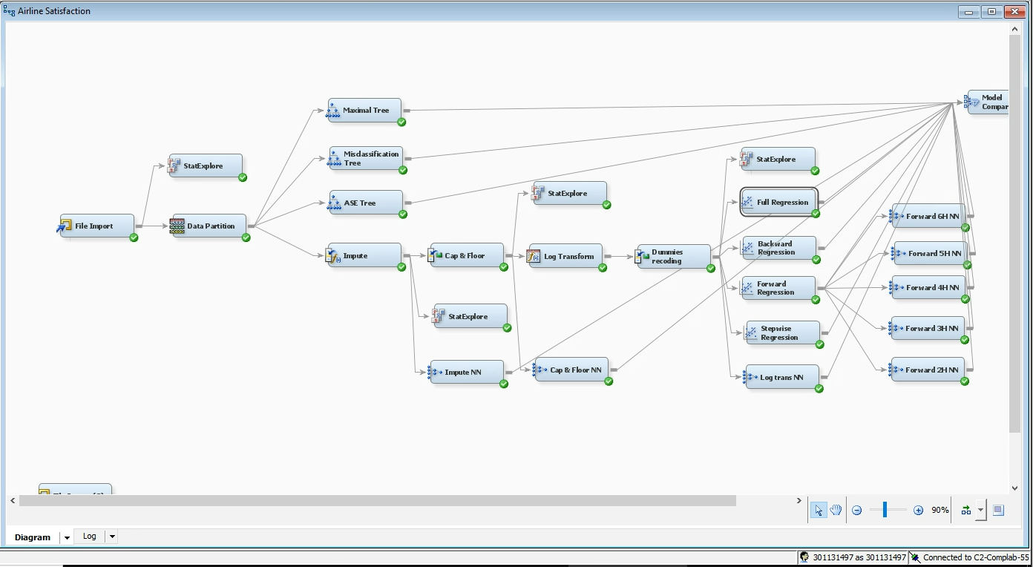

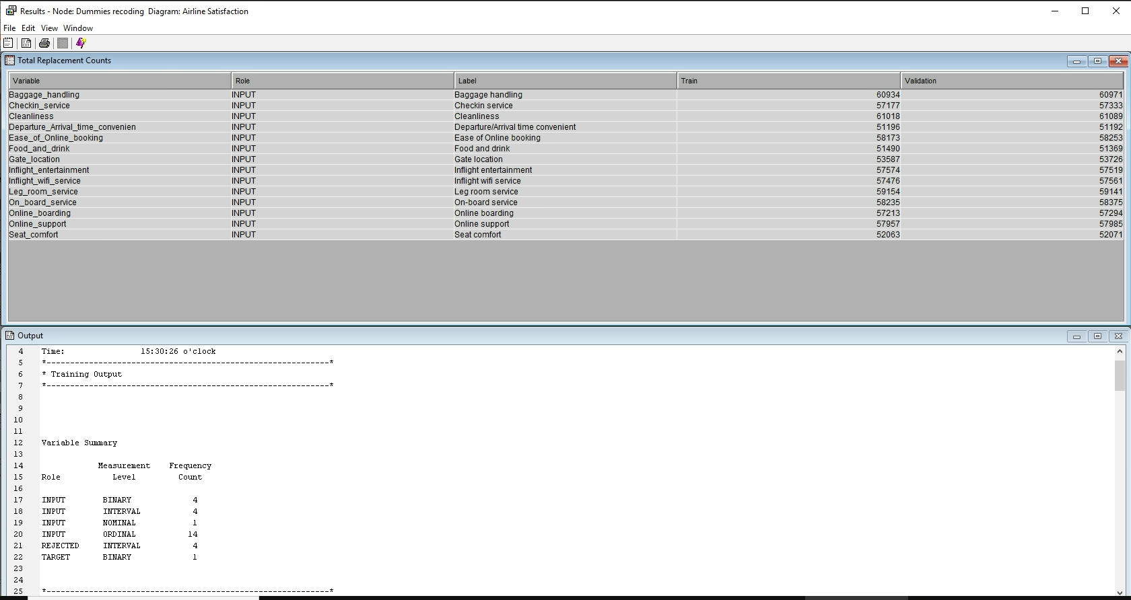

Figure 20: Result of Recoding Dummies node

The result of regression nodes, after recoding dummies, seems not to reduce the complexity of all the models but also increases the ASE of each optimal model and also it is changing the level of importance of each variable.

|  |  |  |  |  |
| --- | --- | --- | --- | --- |
|  | Steps | No. Variables | Important variables | ASE |
| Full Regression | N/A | 23 | Ease_of_Online_Booking, Cleanness, Gate Location, Customer Type & Seat_Comfort,... | 0.0899 (Train)  0.0901 (Vali.) |
| Backward Regression | 1 | 22 | Ease_of_Online_Booking, Cleanness, Gate Location, Customer Type & Seat_Comfort,... | 0.0899 (Train)  0.0901 (Vali.) |
| Forward Regression | 20 | 20 | Ease_of_Online_Booking, Cleanness, Gate Location, Customer Type & Seat_Comfort,... | 0.0899 (Train)  0.0901 (Vali.) |
| Stepwise Regression | 20 | 20 | Ease_of_Online_Booking, Cleanness, Gate Location, Customer Type & Seat_Comfort,... | 0.0899 (Train)  0.0901 (Vali.) |

Table 4: Regression models’ output after recoding dummies

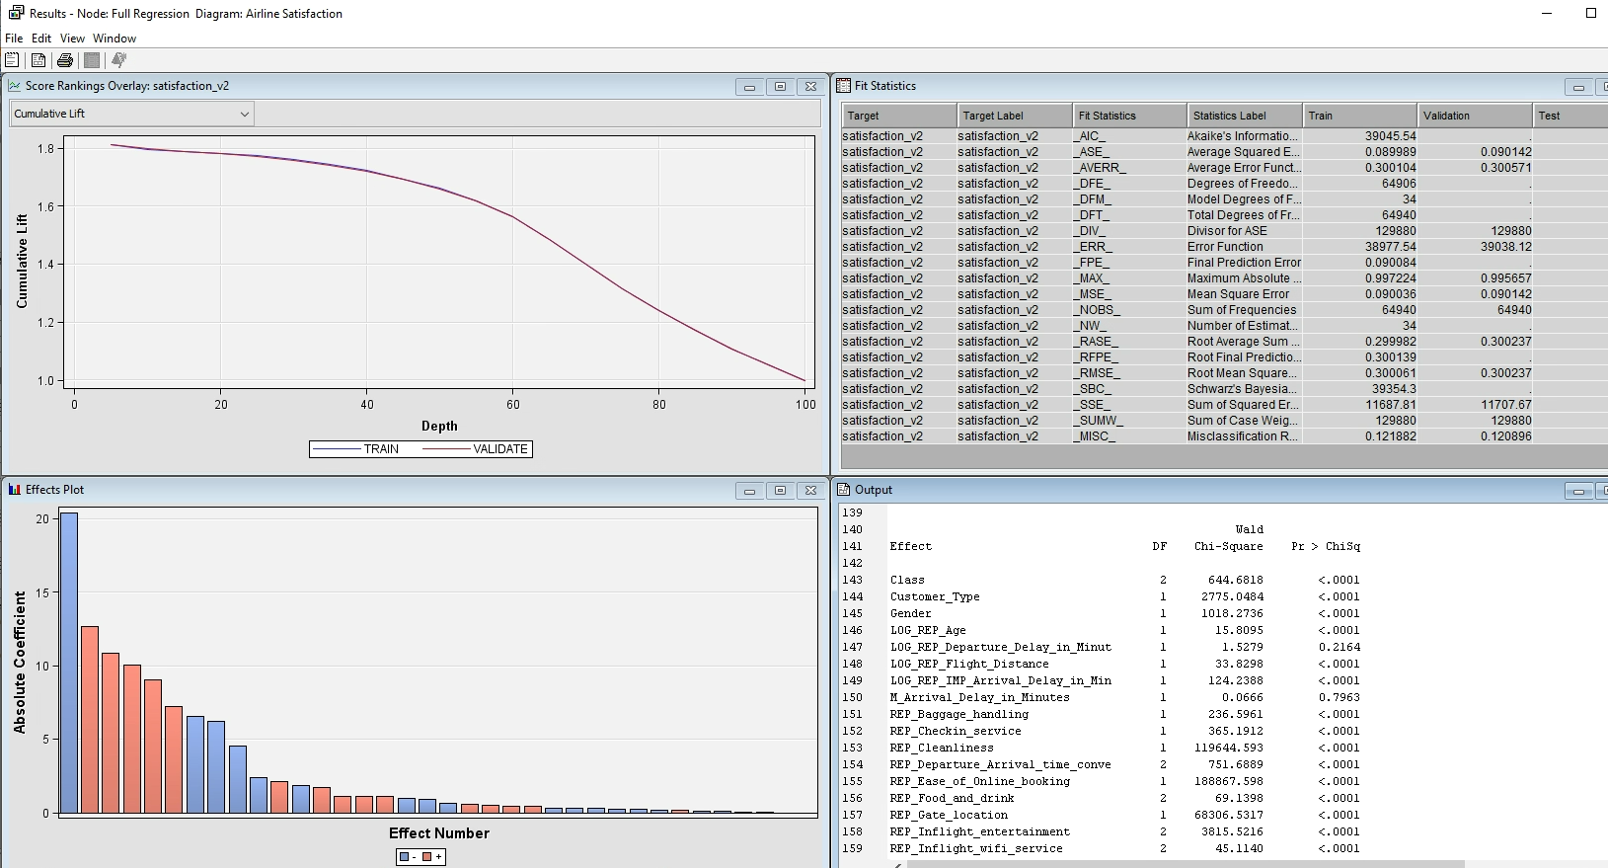

Figure 21: Full Regression output after recoding dummies

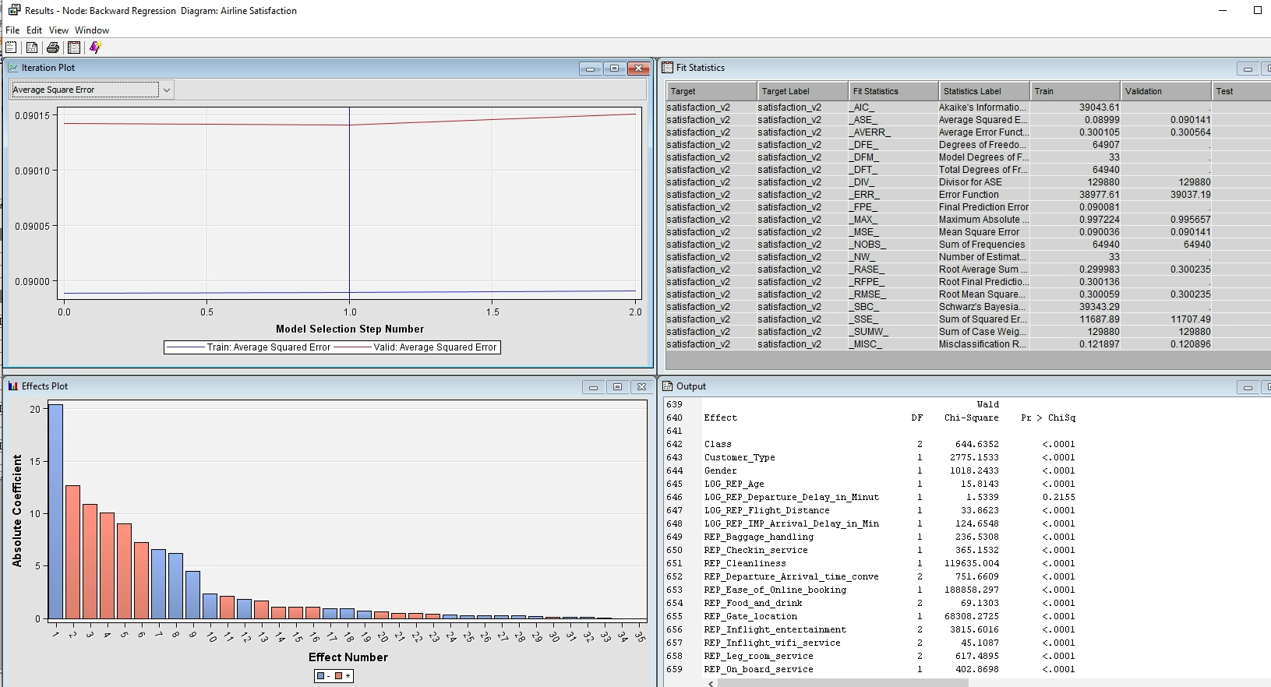

Figure 22: Backward Regression output after recoding dummies

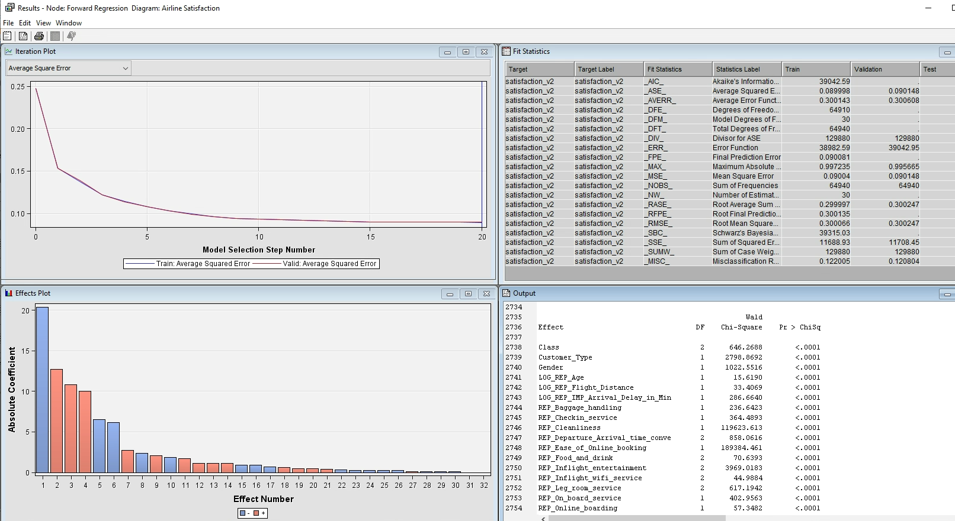

Figure 23: Forward Regression output after recoding dummies

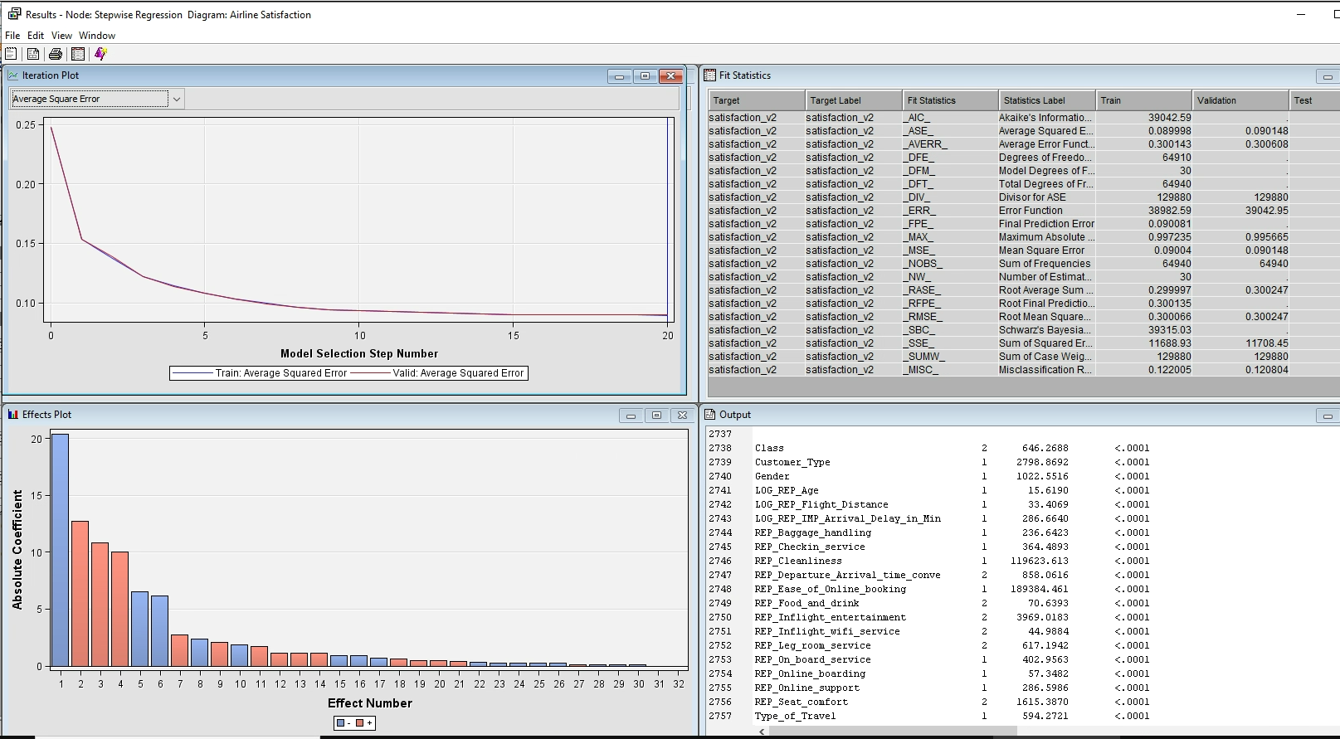

Figure 24: Stepwise Regression output after recoding dummies

I decide to take out the recoding dummies node since this is making the ASE higher and change the importance level of all the variables but not reducing the complexity of the optimal model

# NEURAL NETWORK

I have placed several Neural Network (NN) Nodes:

* After imputed missing values (1 node)
* After Cap & Floor node (1 node)
* After Log Trans node (1 node)
* After Regression Models ( 5 nodes)

For the NN after Regression models, I decided to take the output of the Forward Regression node because, in terms of complexity, it has less complexity with 21 variables, in terms of ASE, it has the same ASE as other models.

I have tried several maximum interactions for the optimization setting and found down it could reach the optimal model with no more than **340** interactions, so I set ‘340’ as the maximum interactions for all the NN nodes. I also have tried to run different NN models with different numbers of hidden units to see the changes.

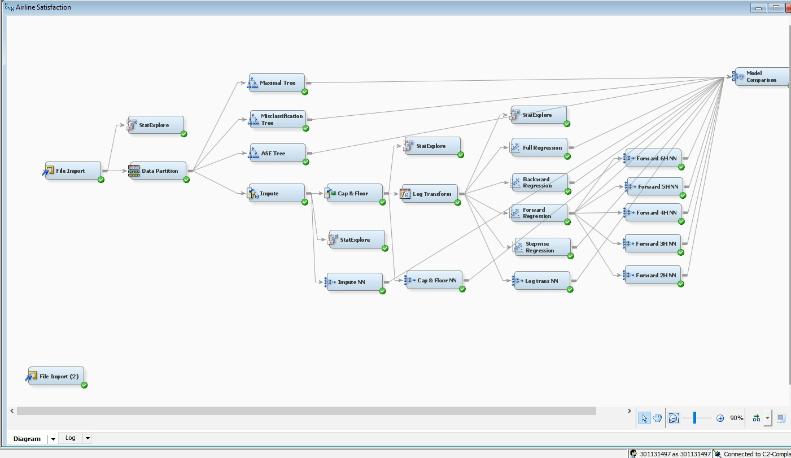

Figure 25: Full analysis diagram

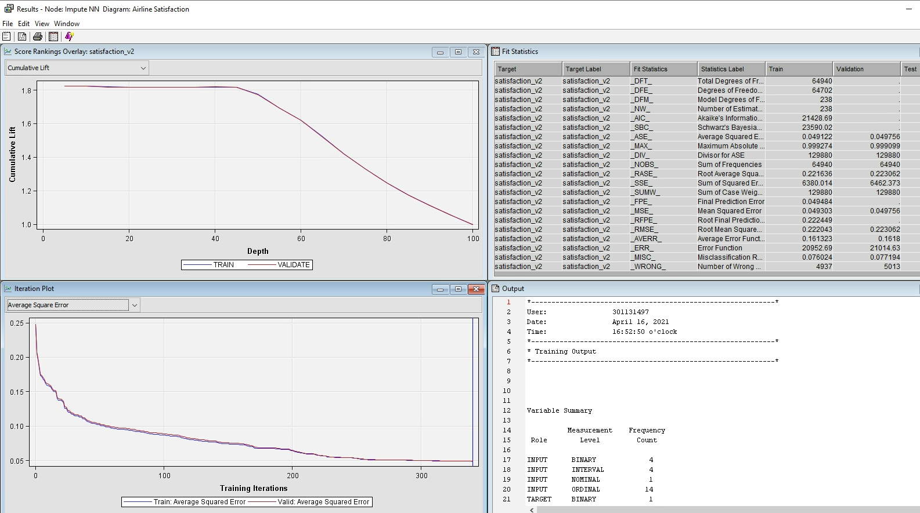

Figure 26: Impute NN output

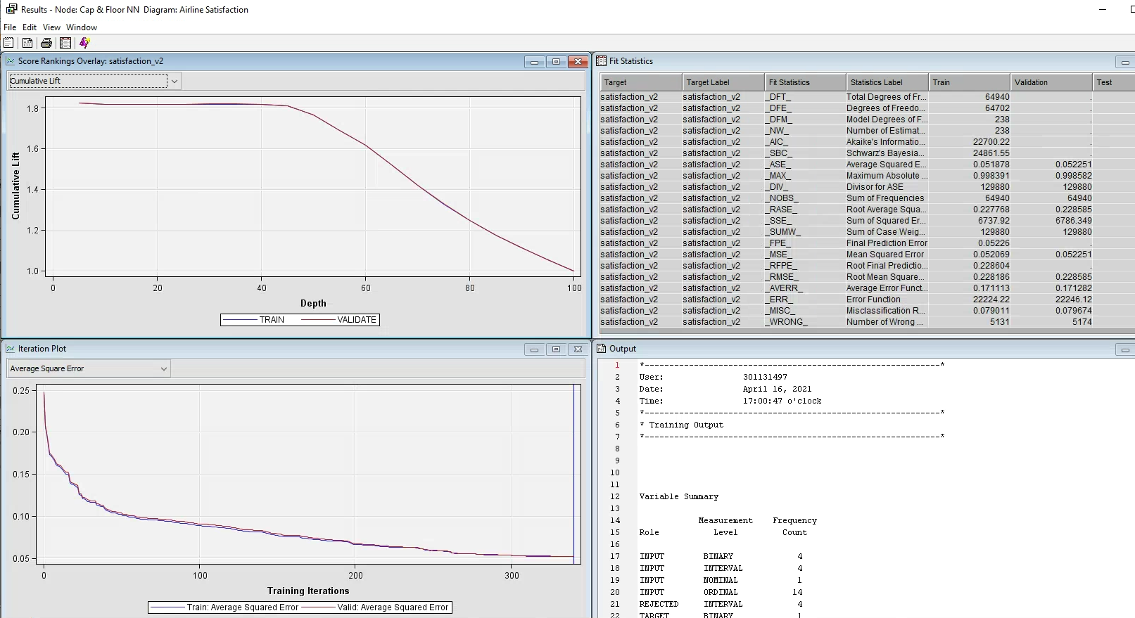

Figure 27: Cap & Floor NN output

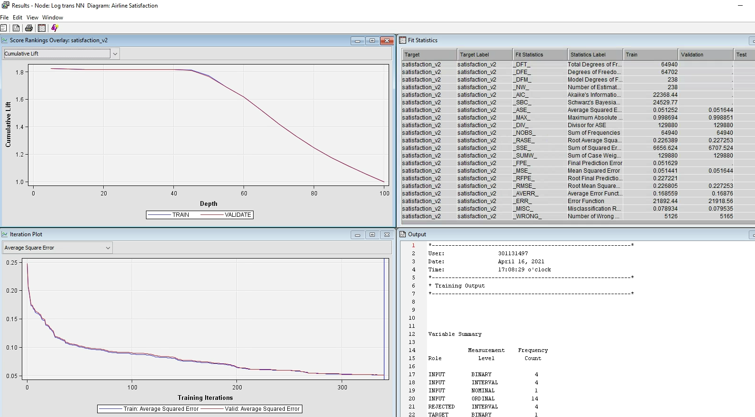

Figure 28: Log trans-NN output

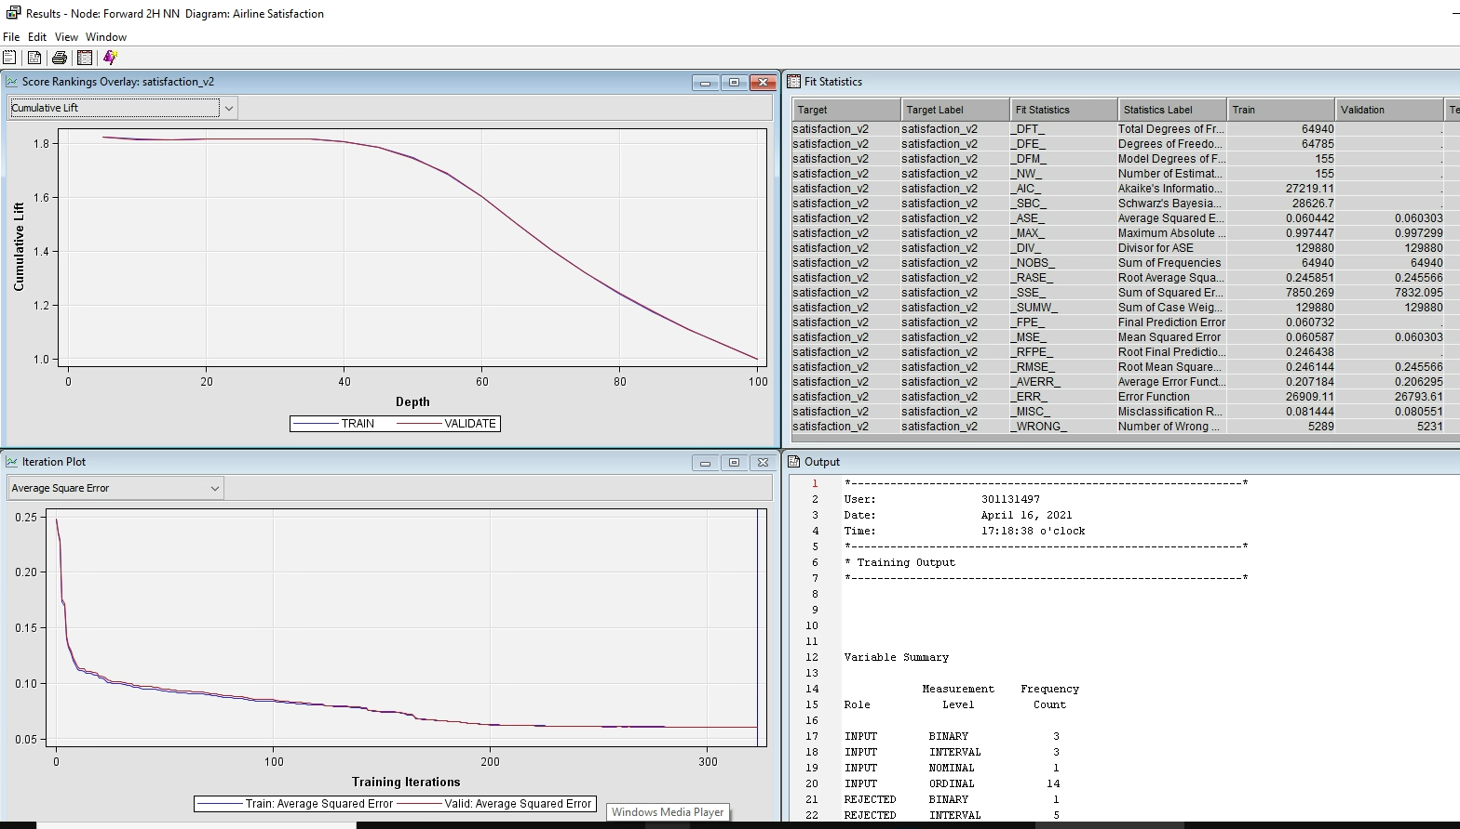

Figure 29: Forward 2H NN output

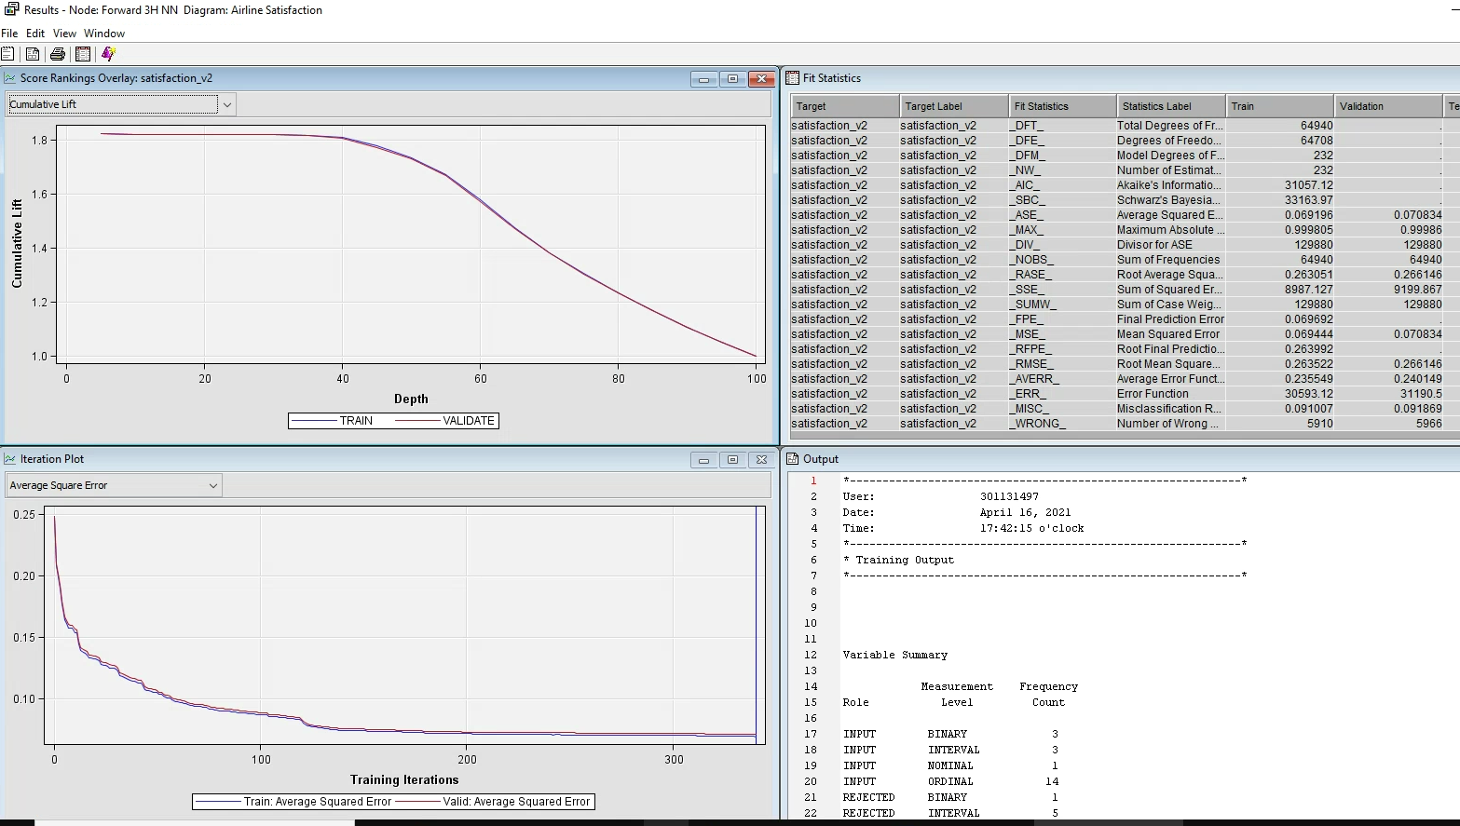

Figure 30: Forward 3H NN output

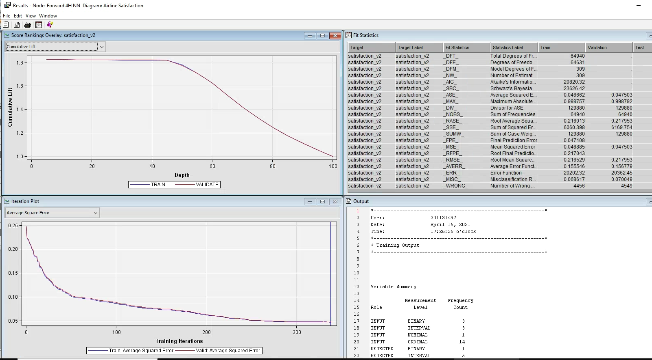

Figure 31: Forward 4H NN output

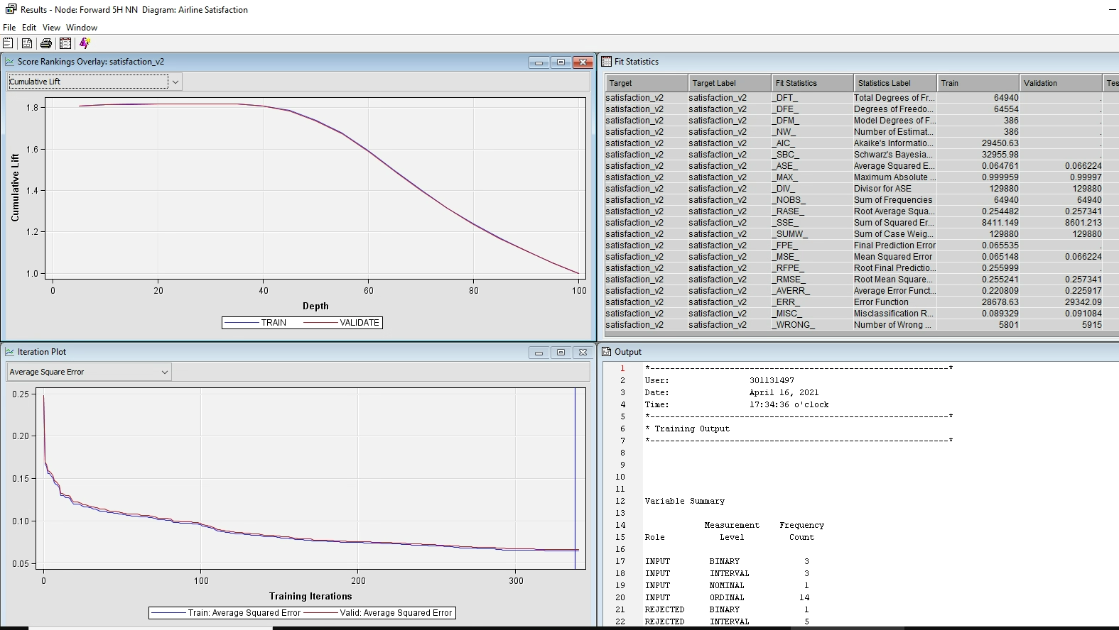

Figure 32: Forward 5H NN output

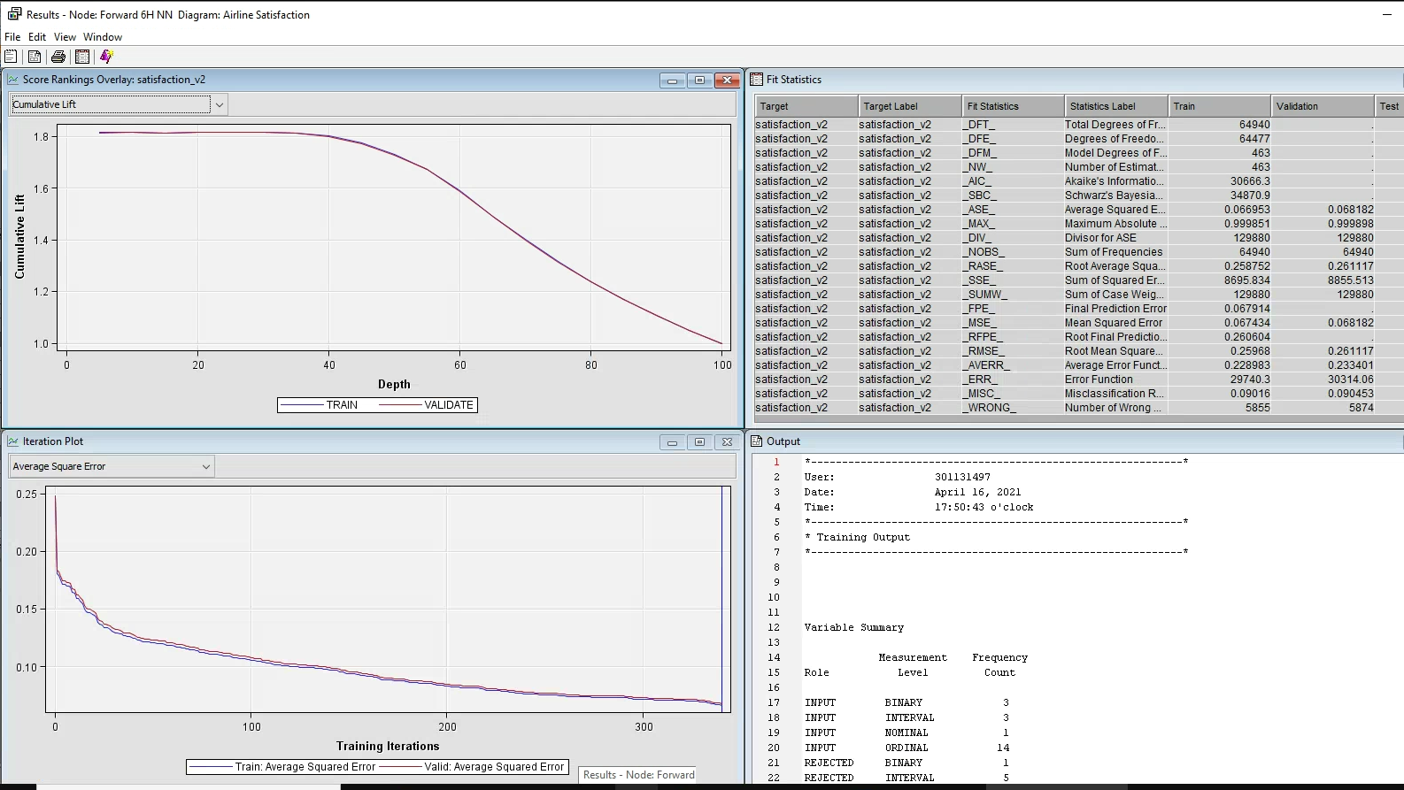

Figure 33: Forward 6H NN output

All the NN models are using average error as the criteria for choosing the best model. According to the results, the best model which has the lowest ASE is Forward 4H NN.

|  |  |
| --- | --- |
| Model Names | ASE of Validation data set |
| Forward 4H NN | 0.047503 |
| Impute NN | 0.049756 |
| Log trans NN | 0.051644 |
| Cap & Floor NN | 0.052251 |
| Forward 2H NN | 0.060303 |
| Forward 5H NN | 0.066224 |
| Forward 6H NN | 0.068182 |
| Forward 3H NN | 0.070834 |

Table 5: ASE of validation data set for each NN model

# MODELS COMPARISON

All the output of every single model is connected to the models' comparison node. After running the node, the result shows that the 4H NN model has the lowest ASE (0.047503) and the highest ROC index (0.984) which is good to predict the outcome of passenger satisfaction.

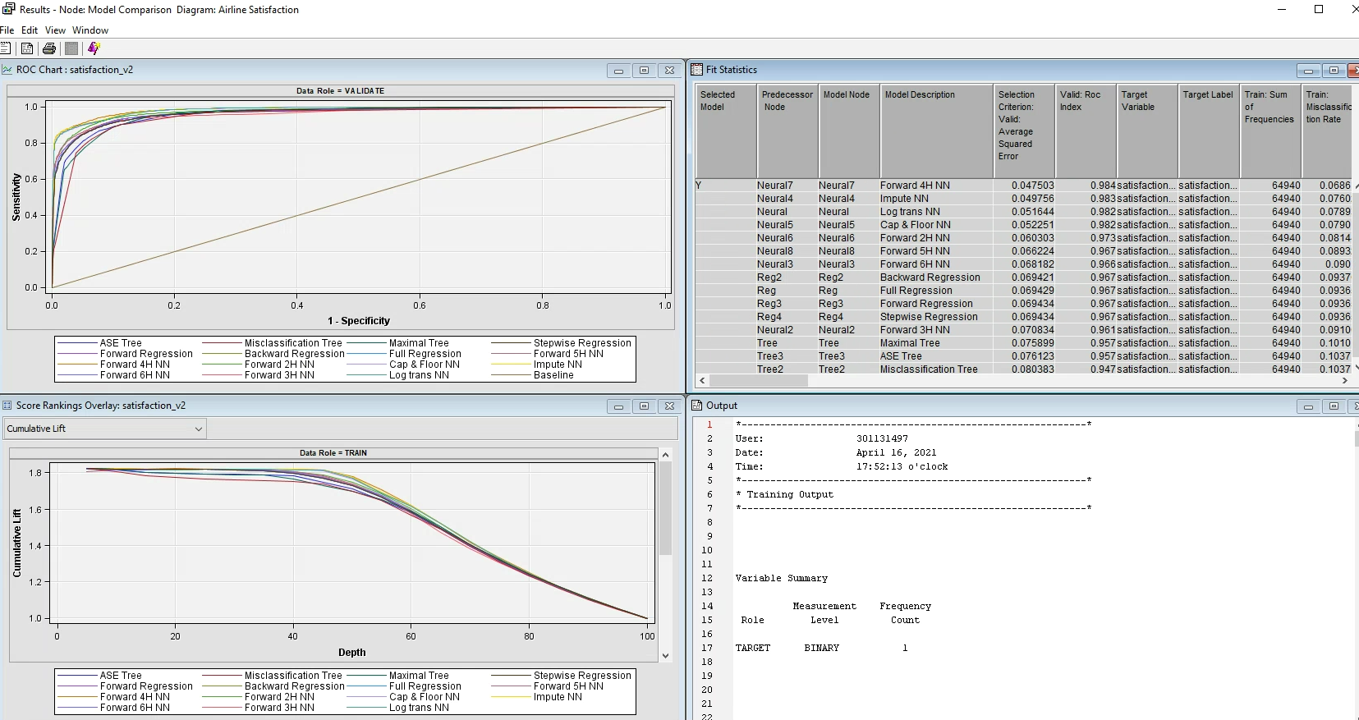

Figure 34: Model comparison output

# CONCLUSION

Most of the variables are important and can be used to predict the outcome of future satisfaction levels of passengers except the Departure Delay Time. Because every variable is important so it leads to the fact that: even the optimal model is complex and involves most of the variables in its model. As a result, the 4 hidden units Neural Network is the optimal model with the lowest Average Square Error (0.047503) and the highest ROC index (0.984) (Backward Regression model has the lowest ASE.

Loyal passengers are more likely to be satisfied with the company’s services than disloyal passengers - more than 14 times (1,4039 %), so it is more necessary to focus on the disloyal customers to increase their loyalty by improving our services. For passengers, some services might be more important than others such as cleanness level, in-flight entertainment, the comfort of seats, the convenience to find gate location. So the company needs to focus on these 5 services to improve the satisfaction level of its passengers in the future.

# REFERENCES

D, J. (2018, June 09). *US Airline Passenger Satisfaction.* Retrieved from Kanggle.com: https://www.kaggle.com/johndddddd/customer-satisfaction

TABLE OF CONTENTS

INTRODUCTION 2

1. Background 2

2. Data set introduction 2

DATA EXPLORATION 4

3. Data importing 4

4. Data Exploration 5

5. Data partition 7

DECISION TREE 8

6. Maximal Tree: 8

7. Misclassification Tree: 10

8. ASE Tree: 12

9. Conclusion for Decision Tree: 14

DATA PREPARATION FOR REGRESSION AND NEURAL NETWORK MODELING 15

10. Imputation Node 15

11. Cap & Floor 16

12. Log Transformation 19

REGRESSION MODELING 21

13. Full Regression 21

14. Backward, Forward, and Stepwise Regression 23

15. Conclusion & Interpretation for Regression Models 25

16. Dummies recoding 27

NEURAL NETWORK 31

MODELS COMPARISON 36

CONCLUSION 37

REFERENCES 38

Figure 1: Variables’ roles and levels assigned by SAS automatically 4

Figure 2: Variables’ roles and levels after re-assigned 5

Figure 3: output of data exploration after the Importing Node 6

Figure 4: Data partition output 7

Figure 5: Decision Tree nodes 8

Figure 6: Maximal Tree output 10

Figure 7: Misclassification Tree output 12

Figure 8: ASE Tree output 14

Figure 9: Imputation results 16

Figure 10: Stat Explorers results after Imputation Node 17

Figure 11: Cap & Floor output 18

Figure 12: Stat Explores results after the Cap & Floor 19

Figure 13: Log Transformation output 20

Figure 14: Exploration of output variables from Log Transformation Node 20

Figure 15: Full Regression output 22

Figure 16: Backward Regression output 23

Figure 17: Forward Regression output 24

Figure 18: Stepwise Regression output 24

Figure 19: Odds ratio estimated of the most important variables 25

Figure 20: Result of Recoding Dummies node 28

Figure 21: Full Regression output after recoding dummies 29

Figure 22: Backward Regression output after recoding dummies 29

Figure 23: Forward Regression output after recoding dummies 30

Figure 24: Stepwise Regression output after recoding dummies 30

Figure 25: Full analysis Modeling 31

Figure 26: Impute NN output 32

Figure 27: Cap & Floor NN output 32

Figure 28: Log trans NN output 33

Figure 29: Forward 2H NN output 33

Figure 30: Forward 3H NN output 34

Figure 31: Forward 4H NN output 34

Figure 32: Forward 5H NN output 35

Figure 33: Forward 6H NN output 35

Figure 34: Model comparison output 36

Table 1: List of data variables and details. 4

Table 2: Regression models’ results 25

Table 3: Recoding dummies rules 27

Table 4: Regression models’ output after recoding dummies 28

Table 5: ASE of validation data set for each NN model 36